.Net Course: rest full api creations

Open vs=> click asp.net core web application

Create project name => moved to select template – asp.net core api

Then enable the open api support then next .

Then automatically create .net project in pre boiler plate code .

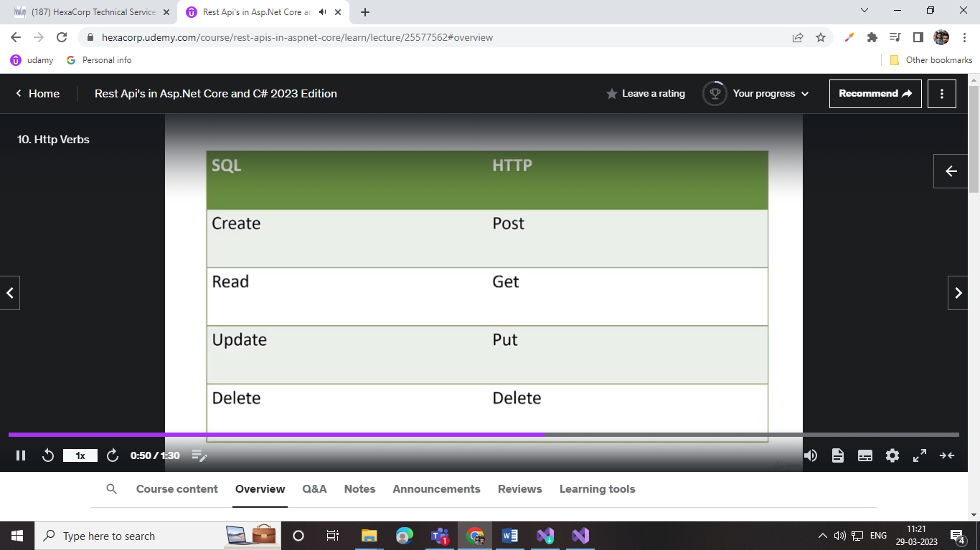

2 – create a models folder it has the models class file create .. its hold the propert of variables

3- create controller add-> new controller -> Api-> api-controller-empty then set the name SongsController

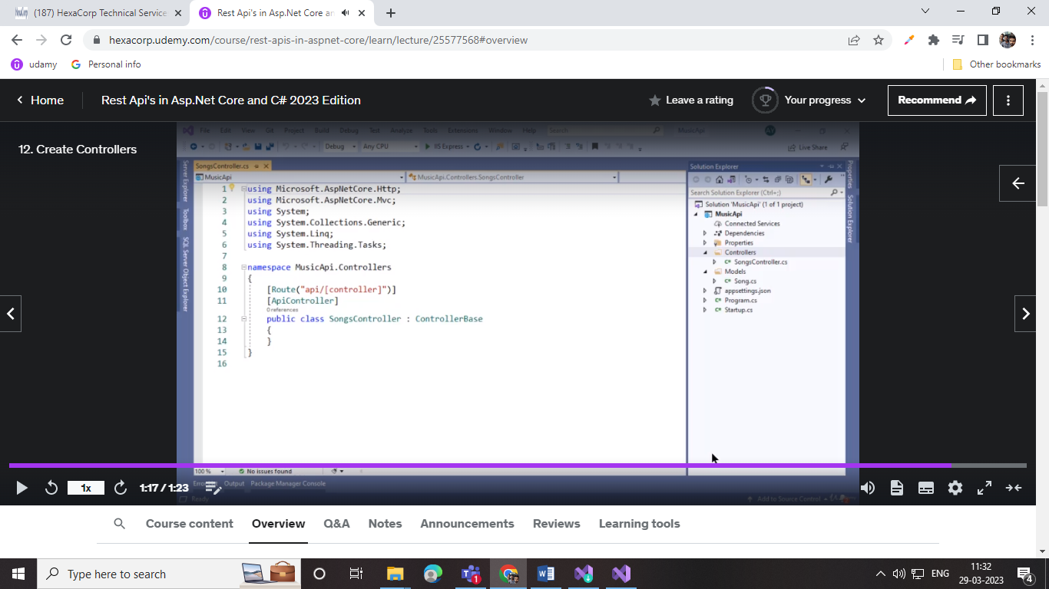

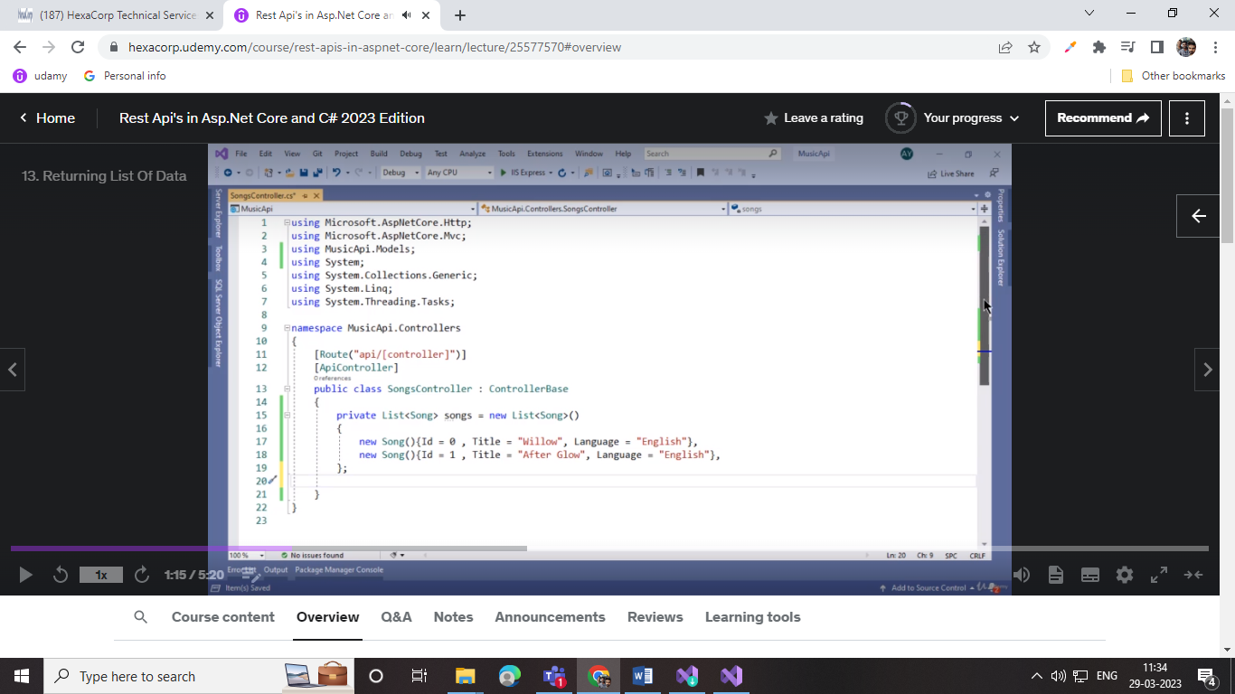

500 error exception handiling -> ippo user data basela illatha datava update or delete pannaagana server error varum so atha solve pann

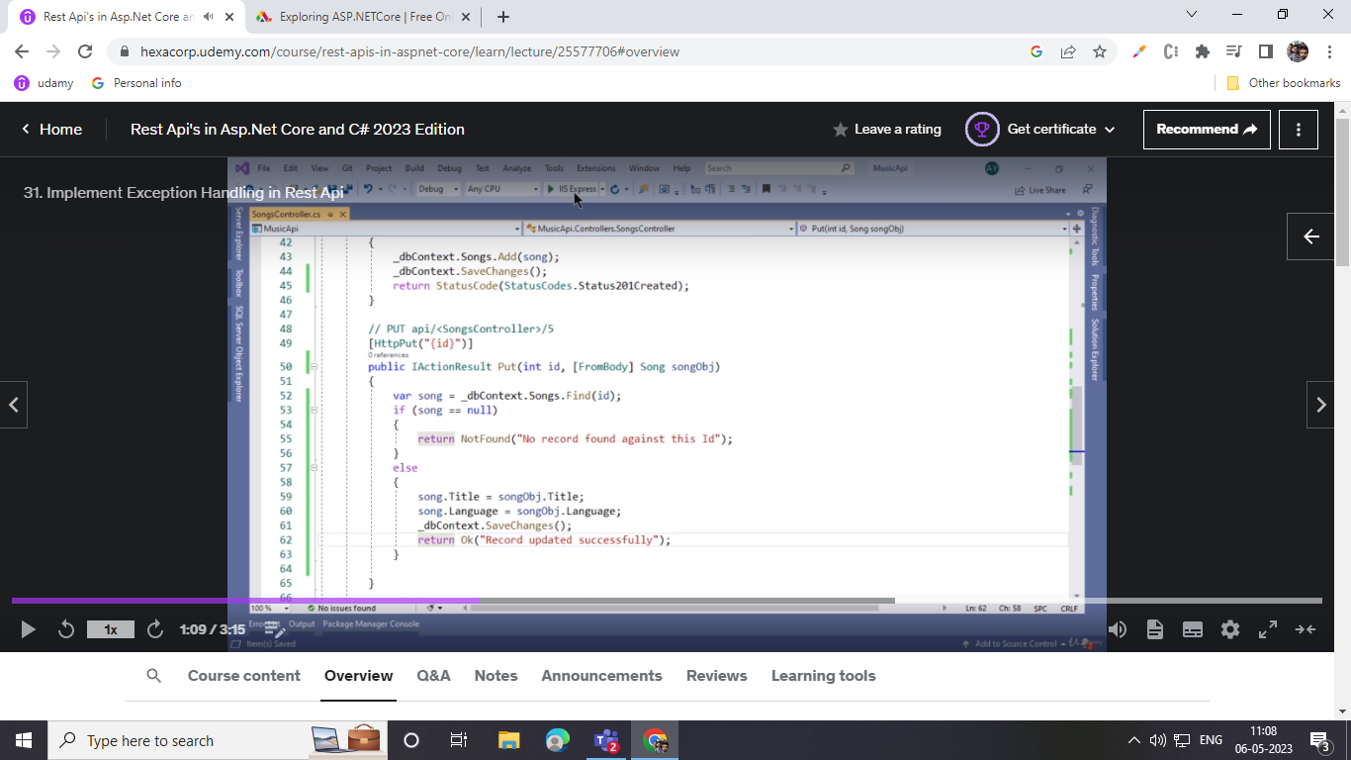

Synchronize process:

Sync one task finish pannotti next process continue aagum

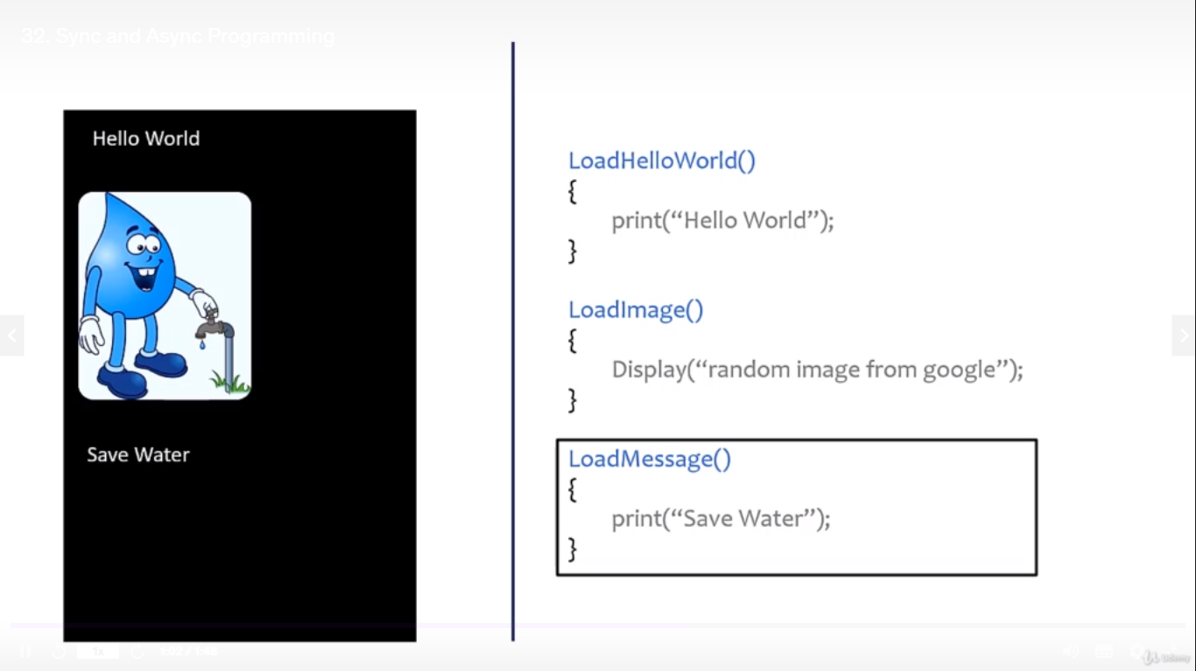

Aysnc entha processkum wait pannathu parlala execute aagitte irukkm . oru process runningla irukka po innoru process run pannikklam athu async

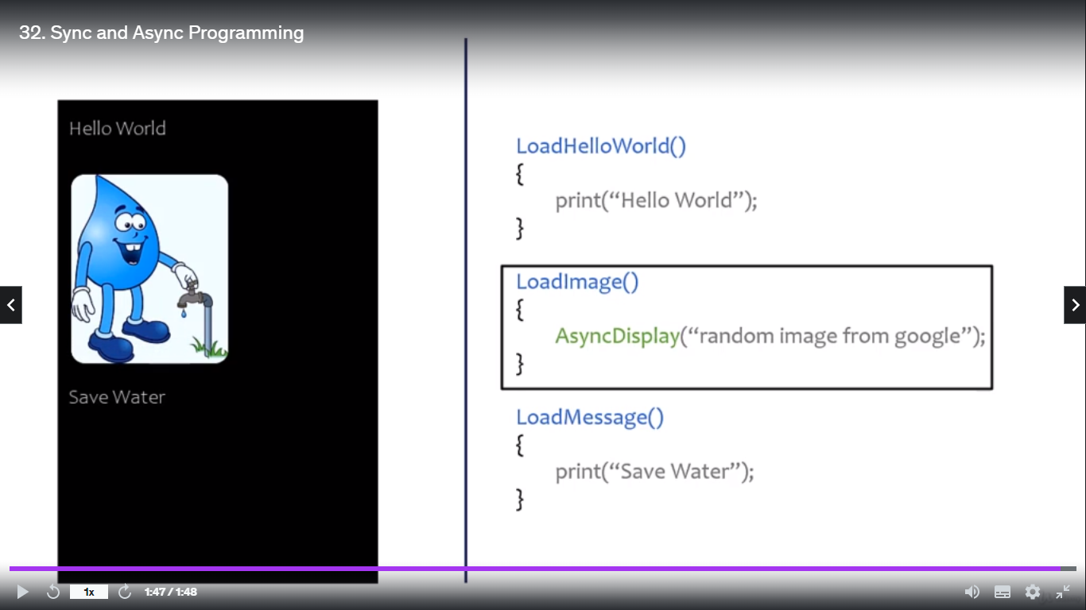

Async and await :await data varrathukkaga waite pannum . ithula task nu irukkurathu athula entha return type venalum set panniklam.

Await enna pannum na aync functionoda data fulla eduthuttu vanthootitha await la irukka line execute pannum .data vara varaikkum await wait pannum keelayum img fulla load aan piragutha displaye work aagum

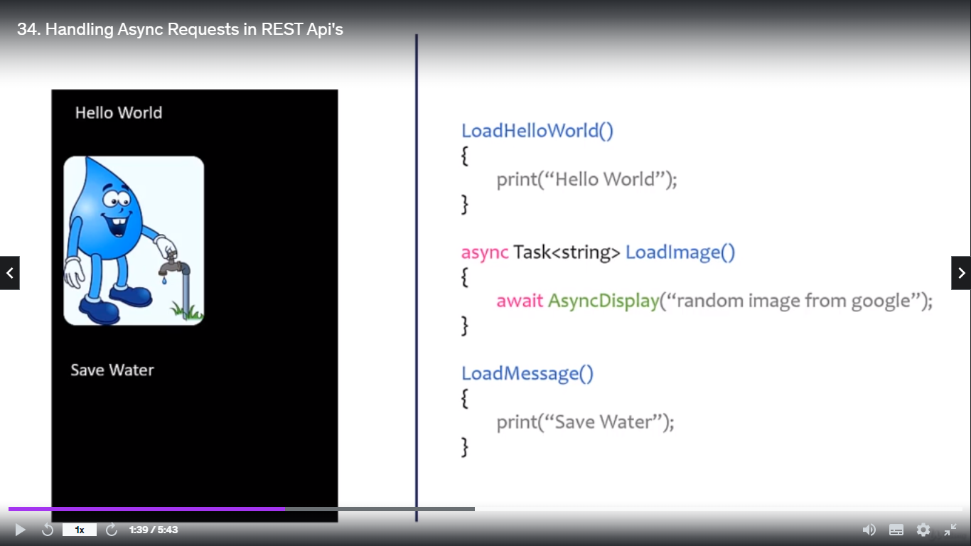

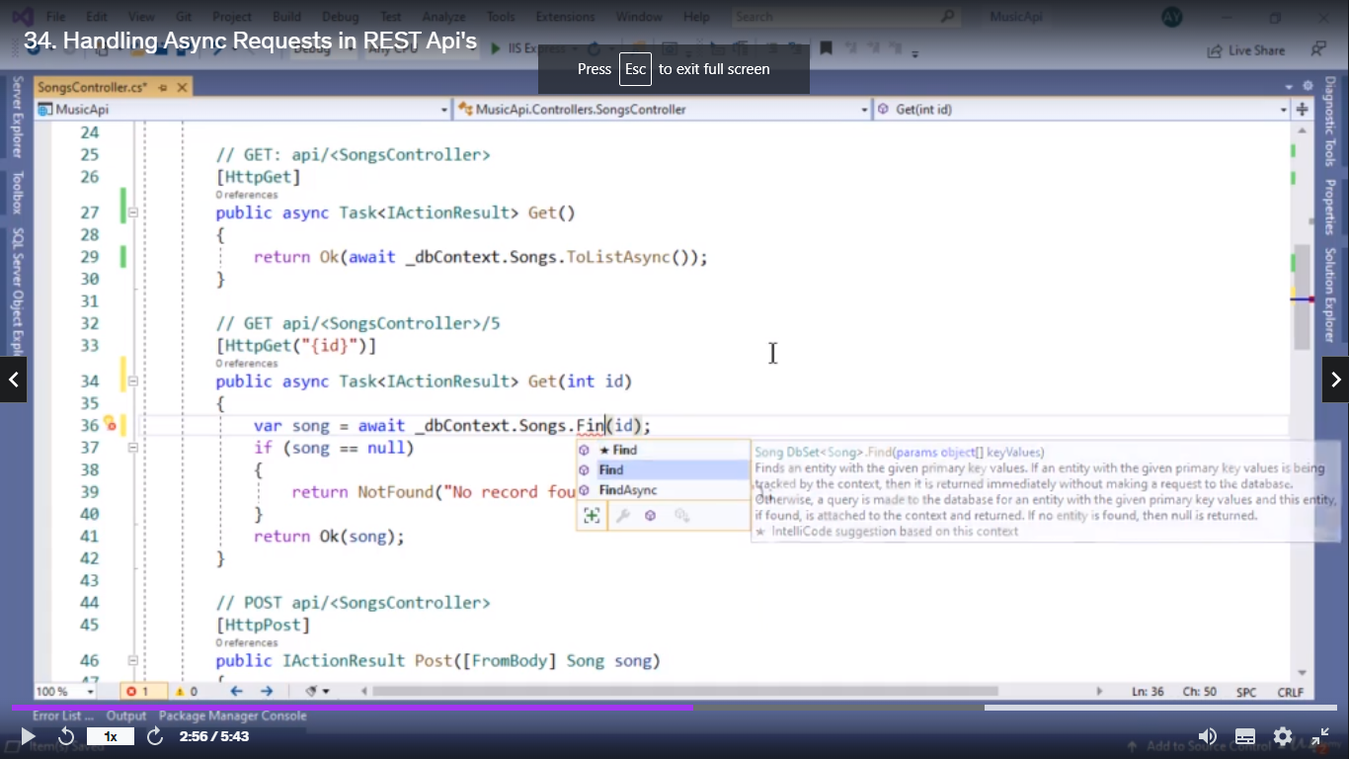

Customa data set panniklam migration ethukkuna db la data table create panna update panna 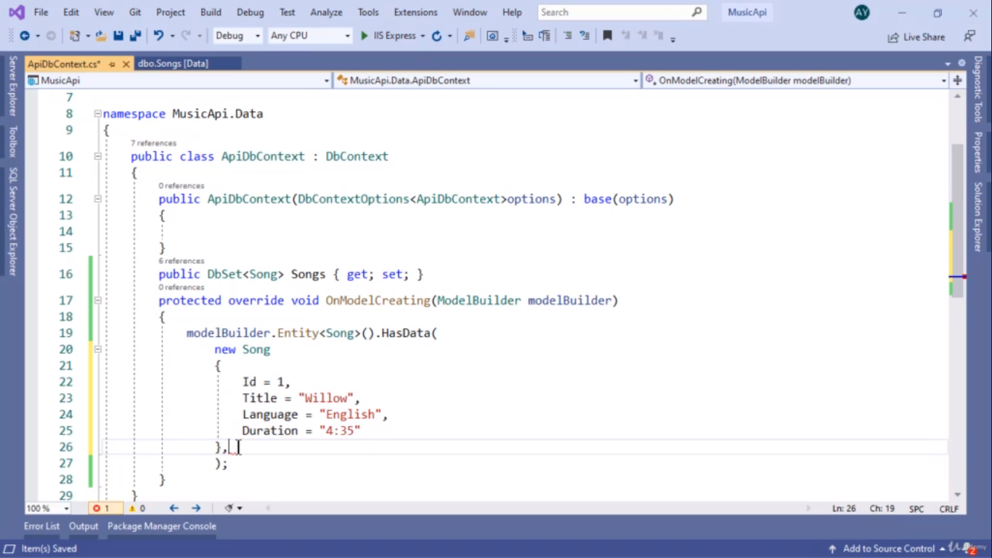

Data inster pannotti migrationku intha omment podanum cutom datakku mattum

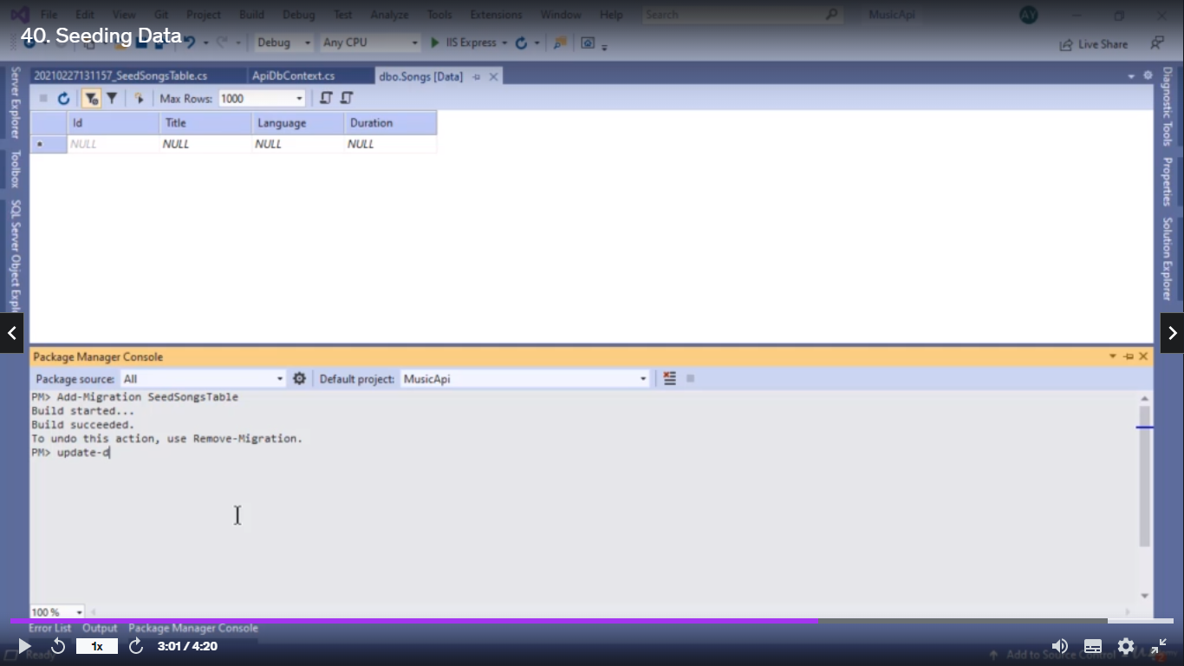

Validation backent : required field emptya iruntha intha error message show aagum console la

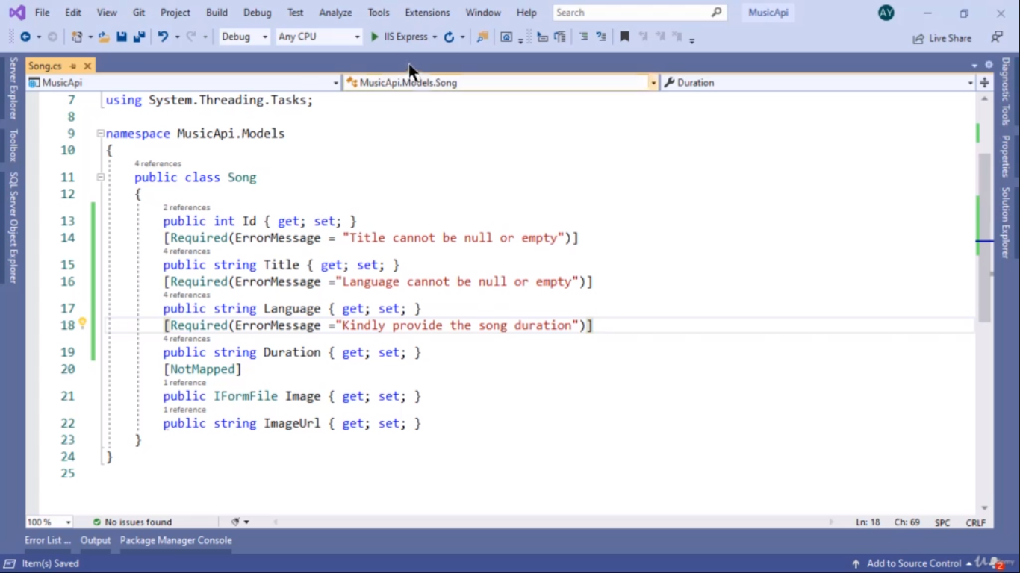

Routing attribute :routing la attribute add panniklam

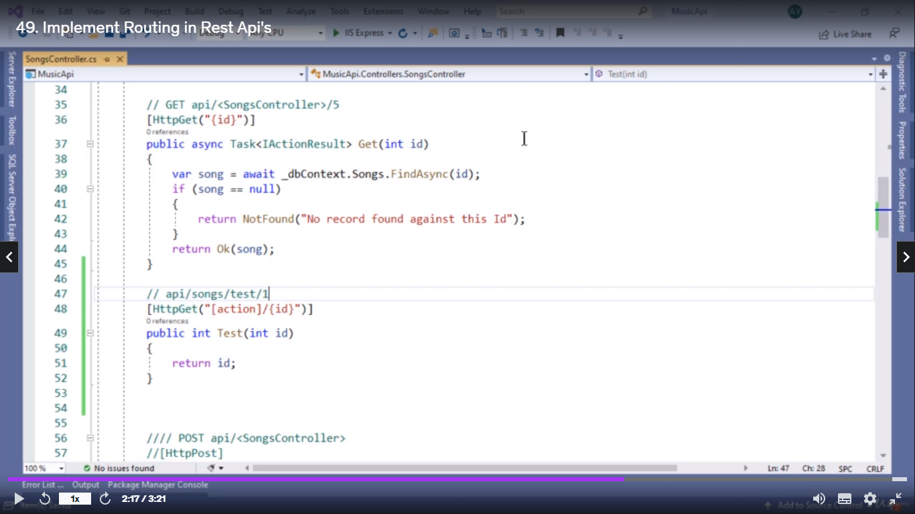

3 model data table la data base la create panniklam

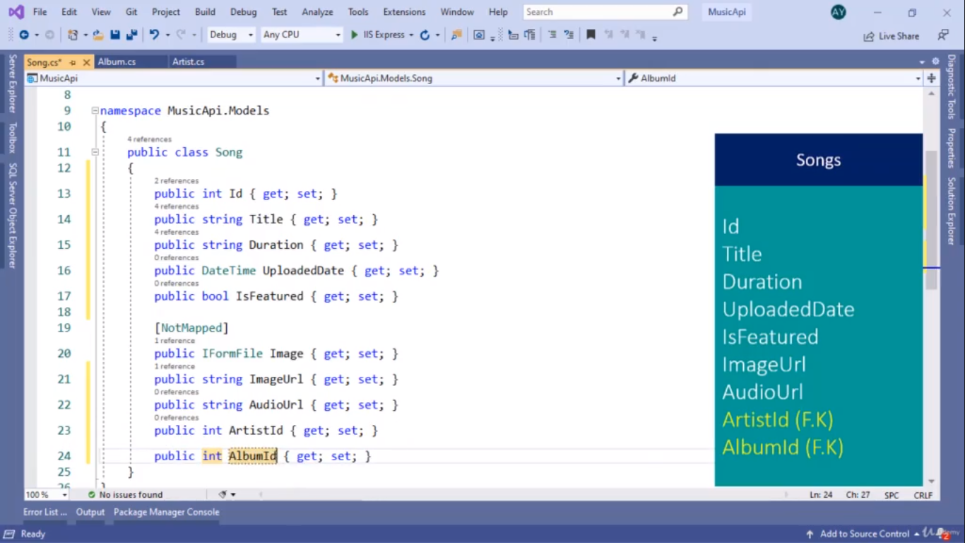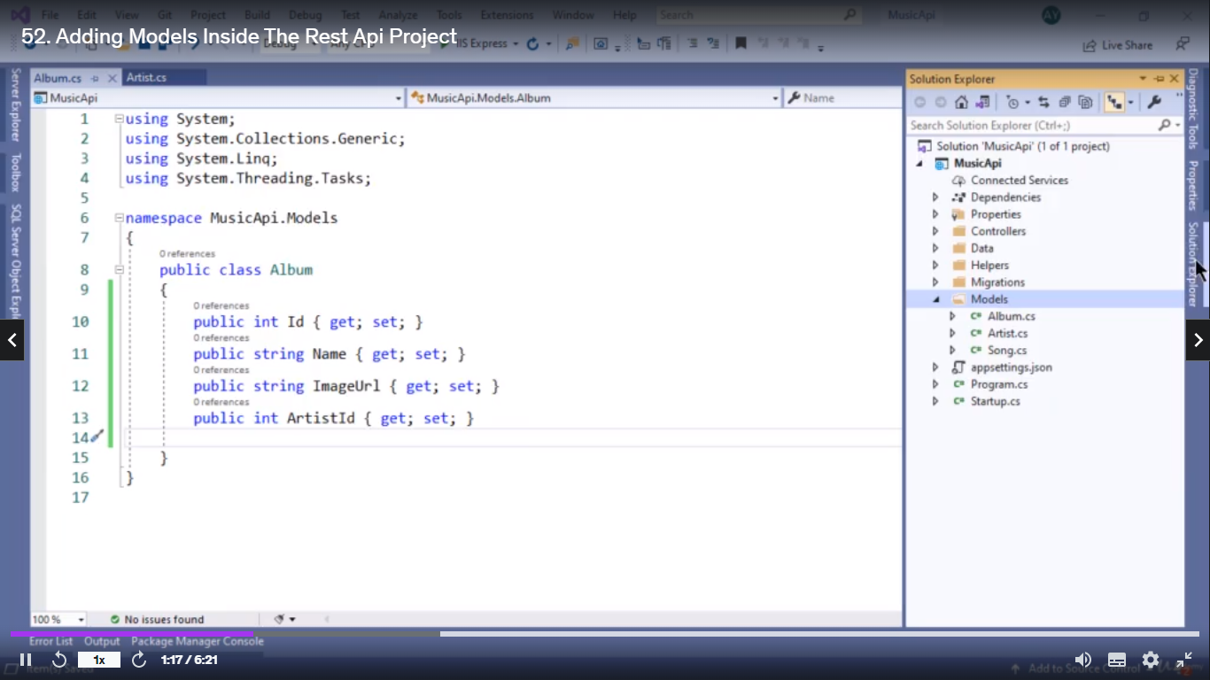

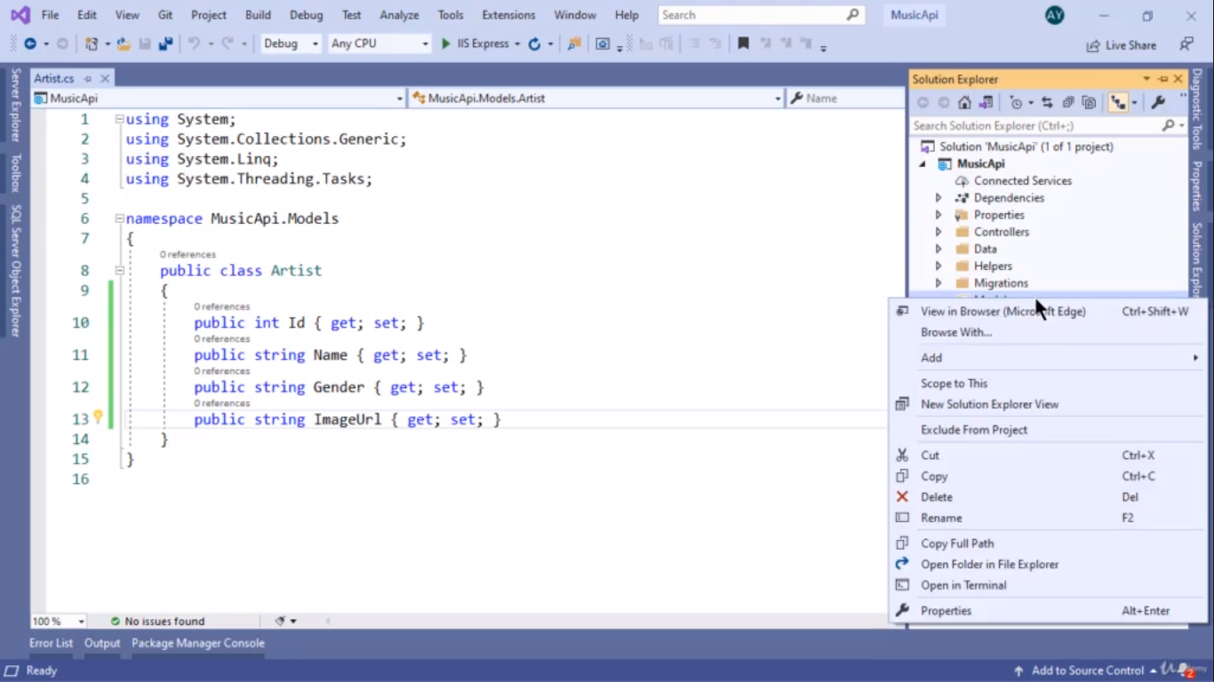

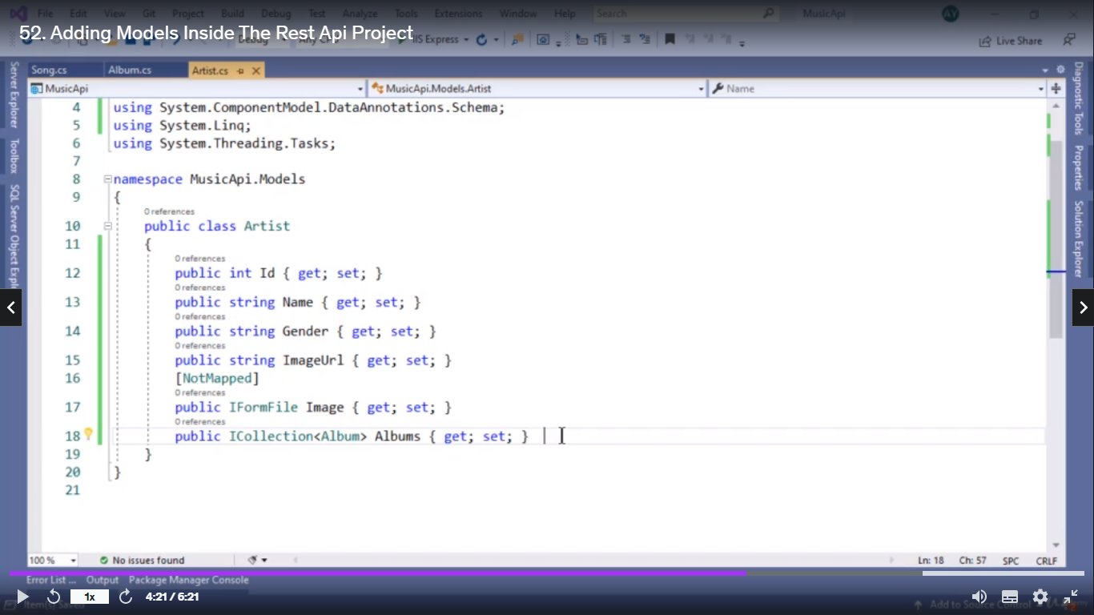

Modela la innoru model access panna (Icolllection method use aaguthu..)

Moonu model namum dbContext la class enter pannaum .

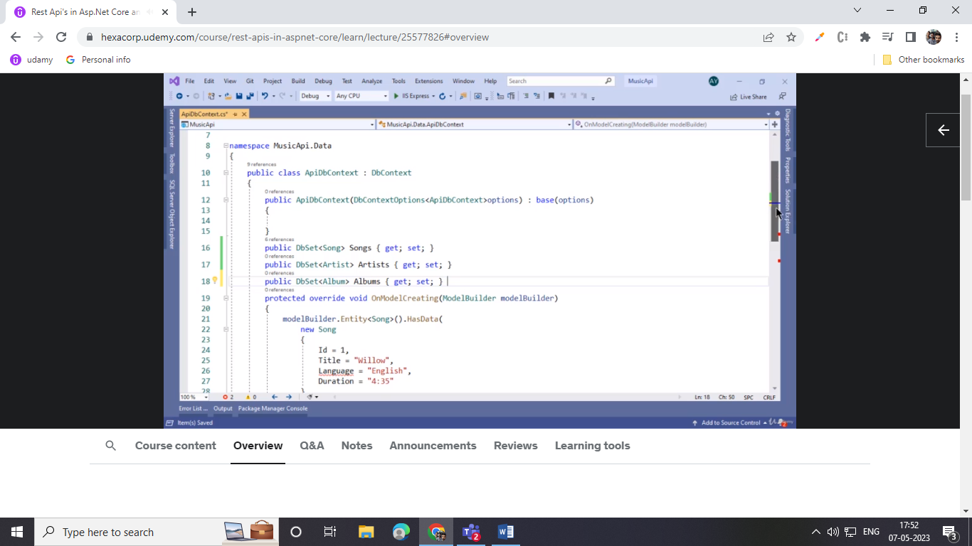

Get methodla overall data edukkurathukku for loop inga angul;ar maariye konjam change aagum let item of ku pathil from name in original data variable name then kedacha values oru varable la stroe pannikklam select new nu

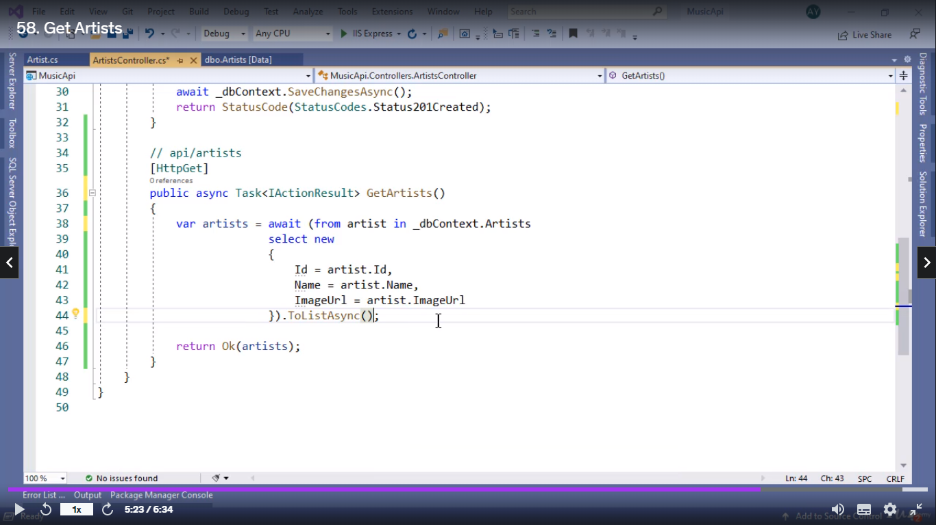

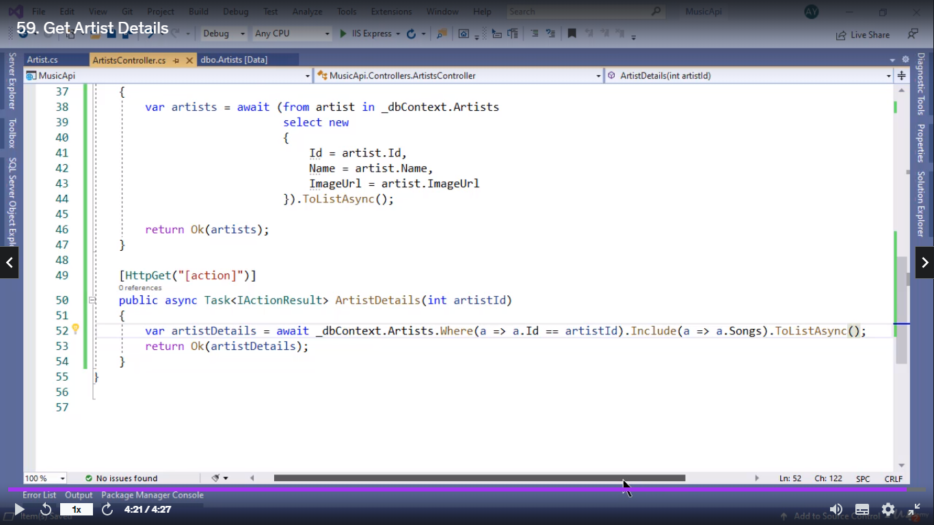

Oru modella innoru model insert panni class create panniruppom ippo oru model data oru controller la data get panna use pannuvom but athe get methodal already insert panna model class la runth data get panna in (include method use panrom). Then oru id kuduthu antha datava iruntha eduthuttu vanu solla if condition (where use panrom)

Entha datavum pass panama condition base panni data return panrathu

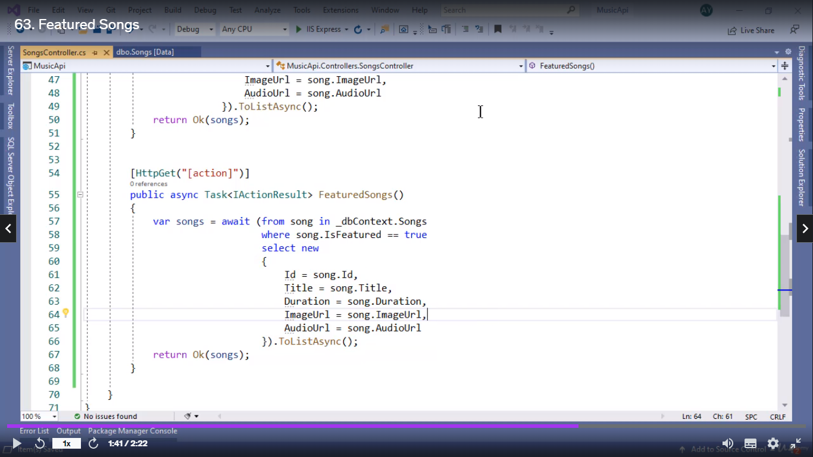

Ippo current data firstum then old dat keelayum use panna (decenting metho) then old data first new data last (assenting method) use pannaum data la ues panna order by key

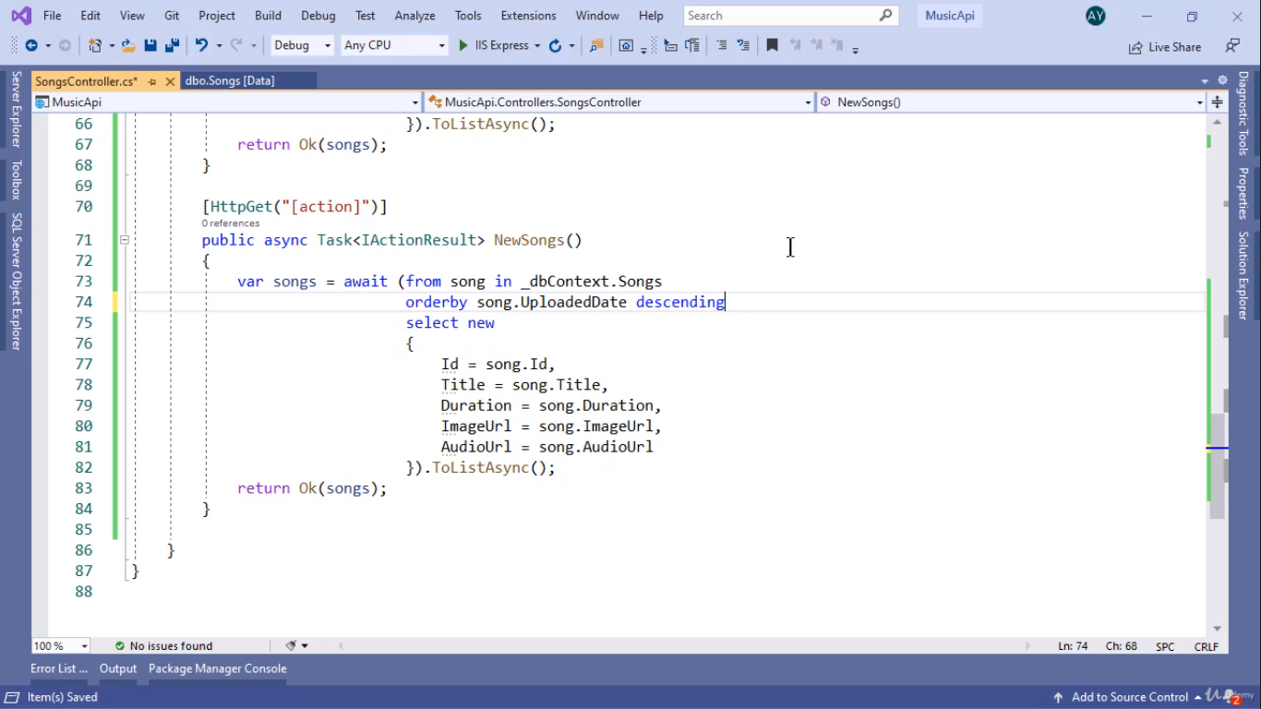

Namakku ethan dat venumnratha kooda take methoda la kudutha avlo data retrun panum

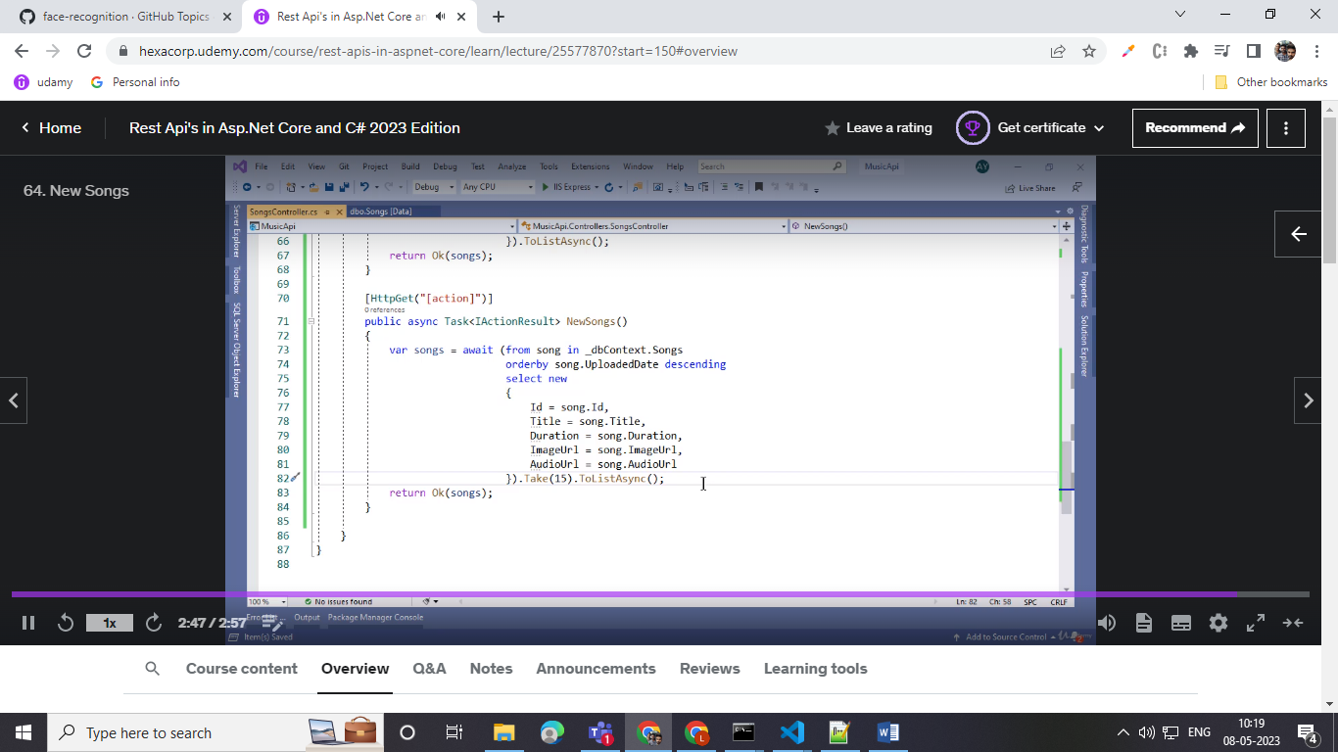

Search option use panrathukku get methodal oru query podanum athula tha user type panra letters irukkum antha method kulla where condition la model name athula irukka property athoda satting letters == user enter panna query leeter

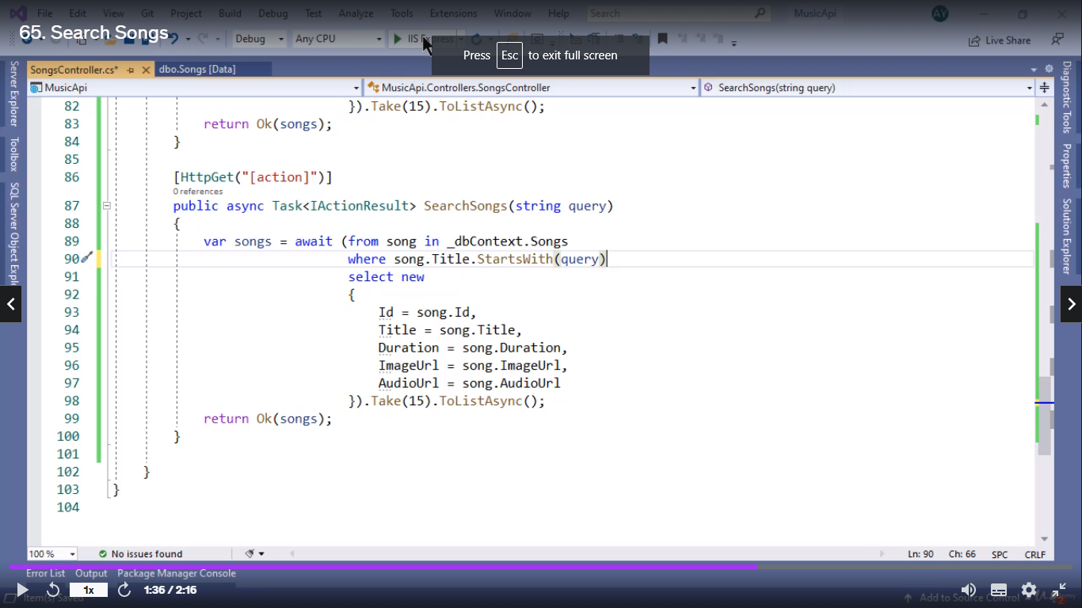

Pagging panniklam .net laye

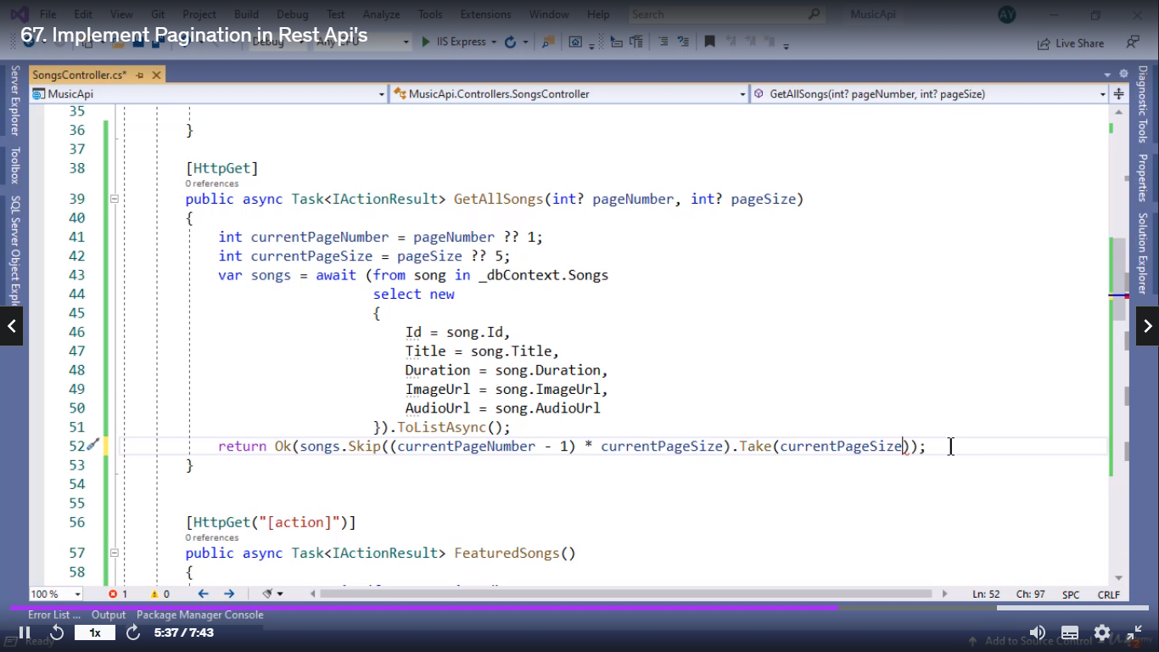

Page number kuduthu athula inthana data tha iruykkanumn set panniklam

Namba panna .net rest api ellam iis nu oru server la deploy pannikklam

.netlaye modela validation use panniklam

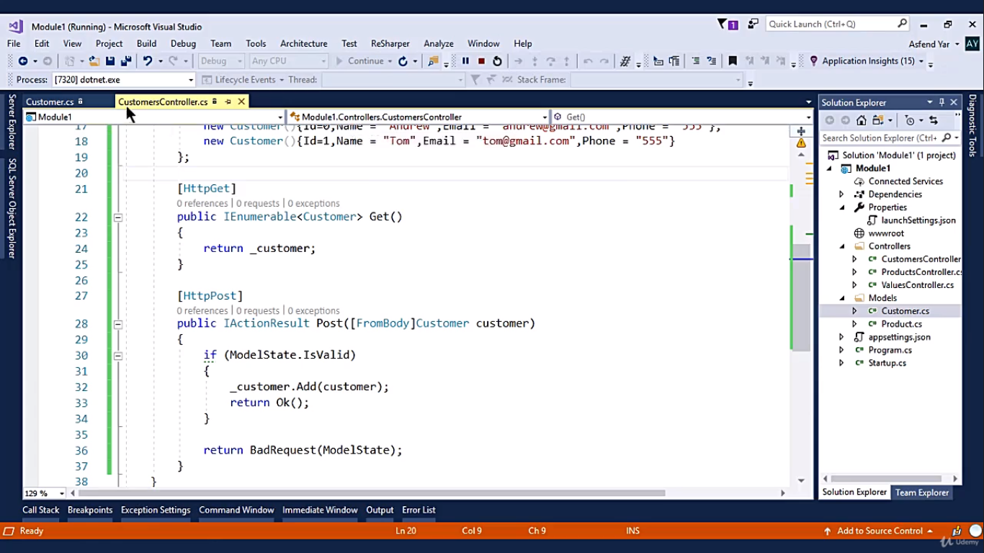

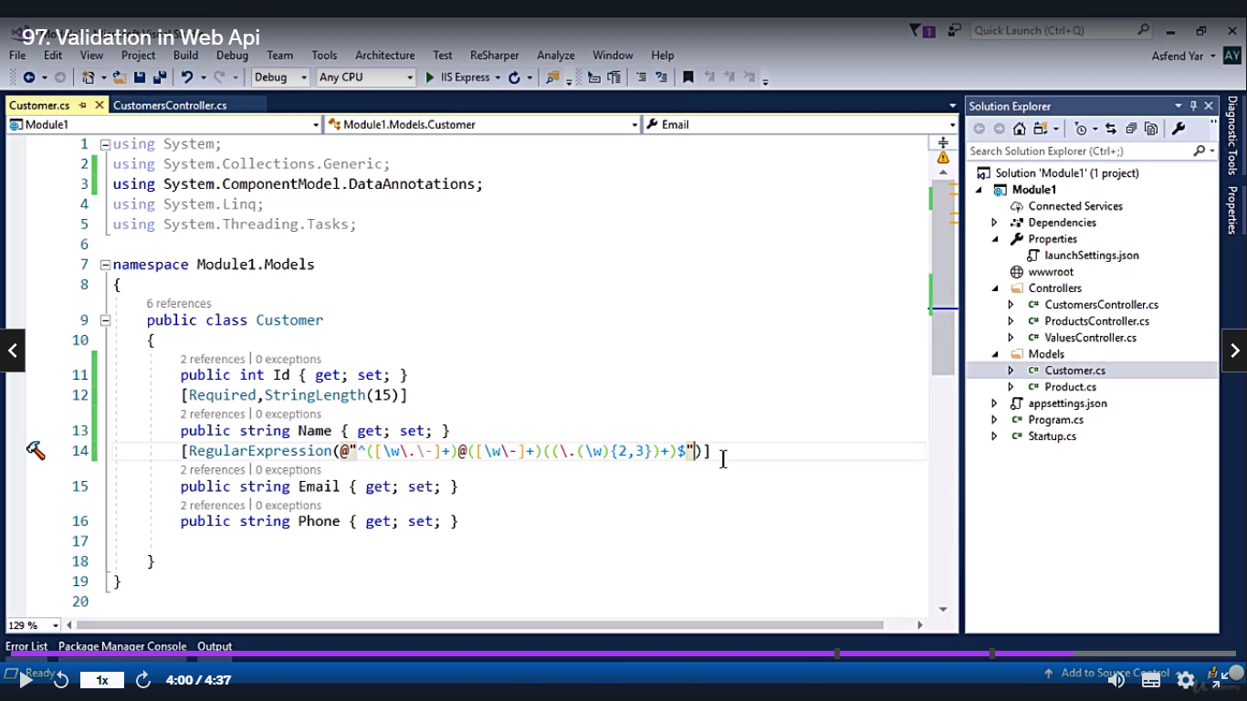

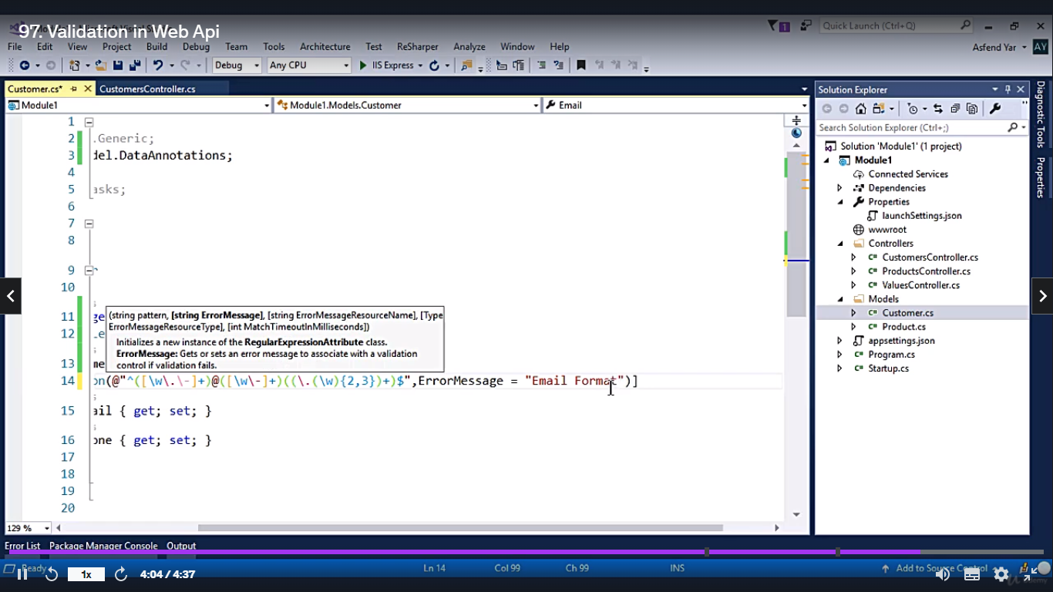

Project create panni work panrathu

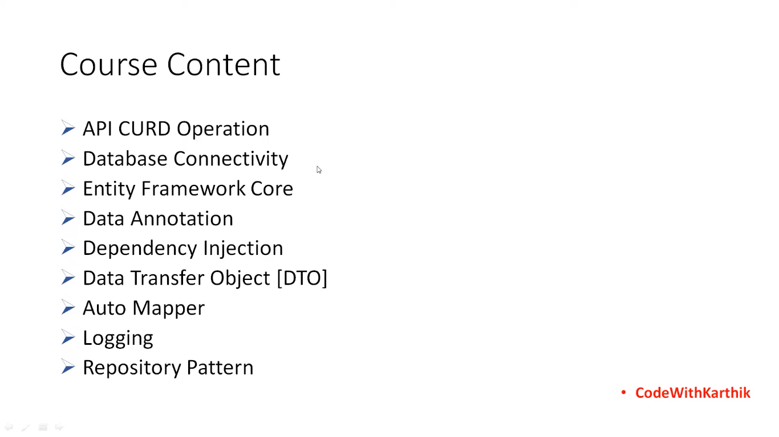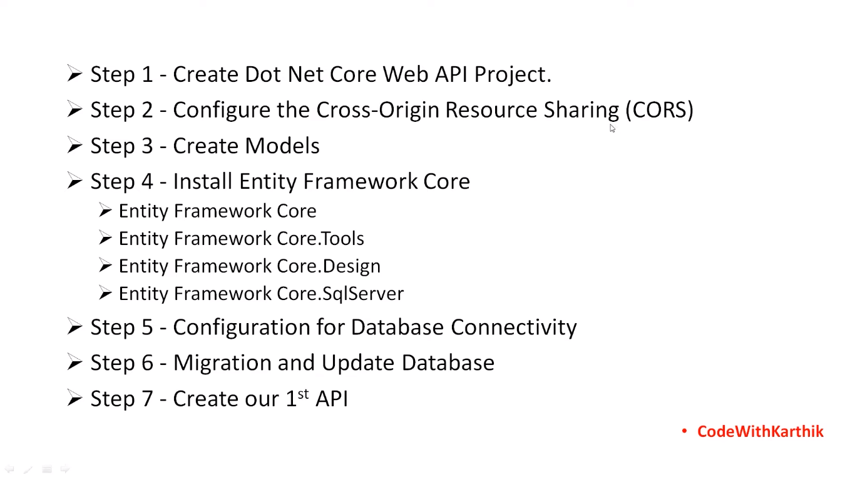

Basic configuaration difrent platform la work aaganum namba api so cors configure

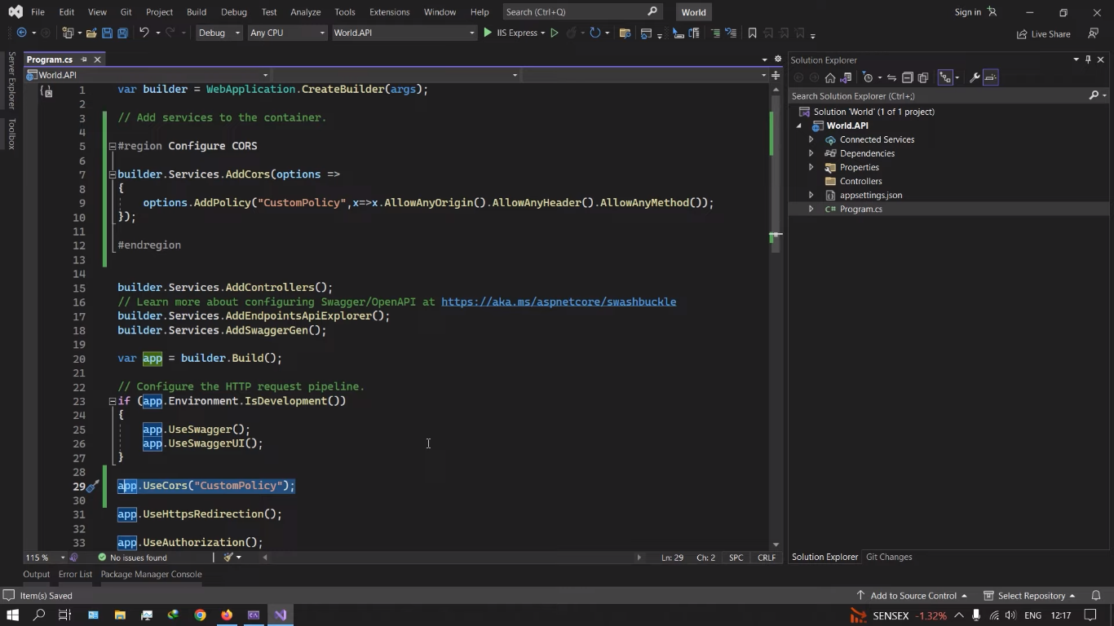

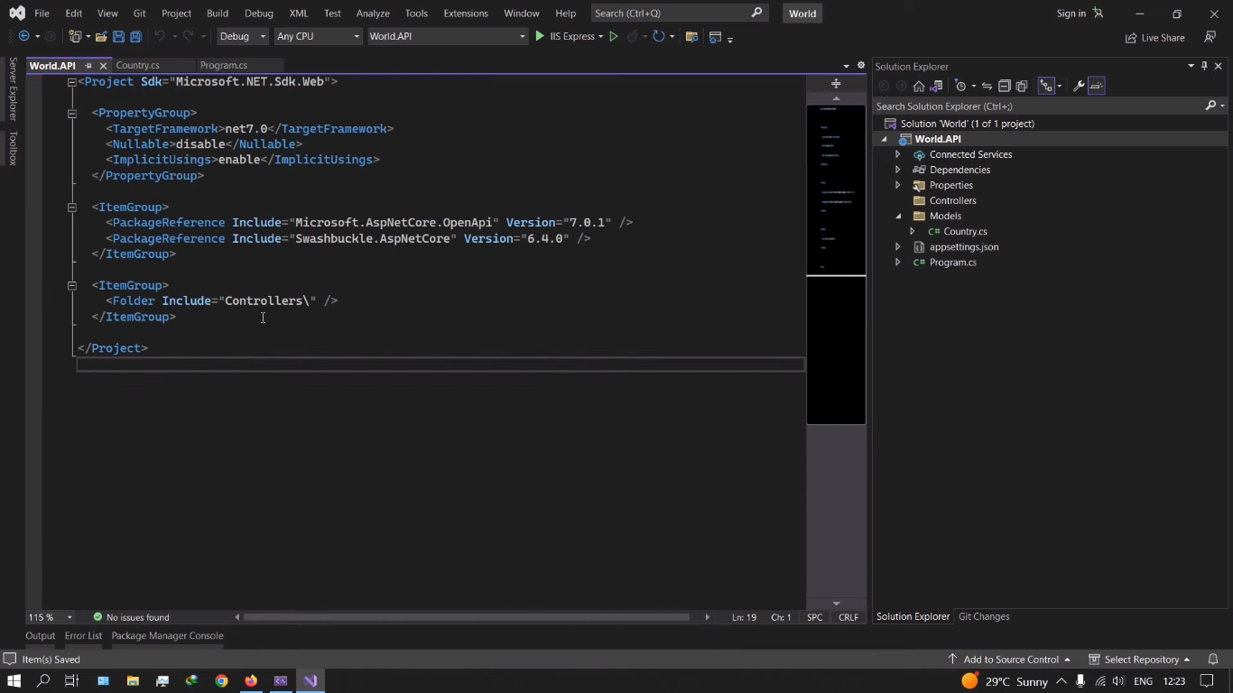

Model la value null kudunu error varum athukku project mela click panna xml open aagum athula null disable pannaum appo anth awarning kaatathu

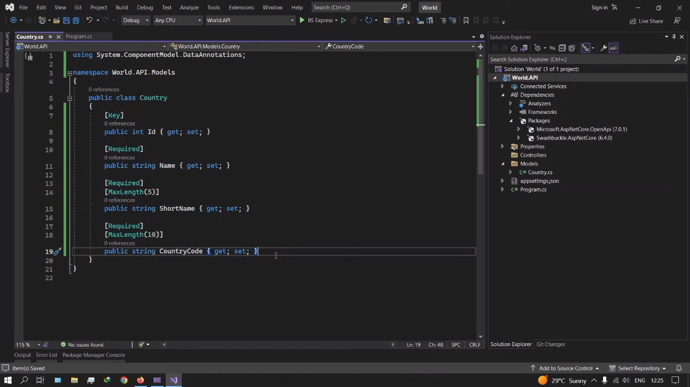

Db connectivity:

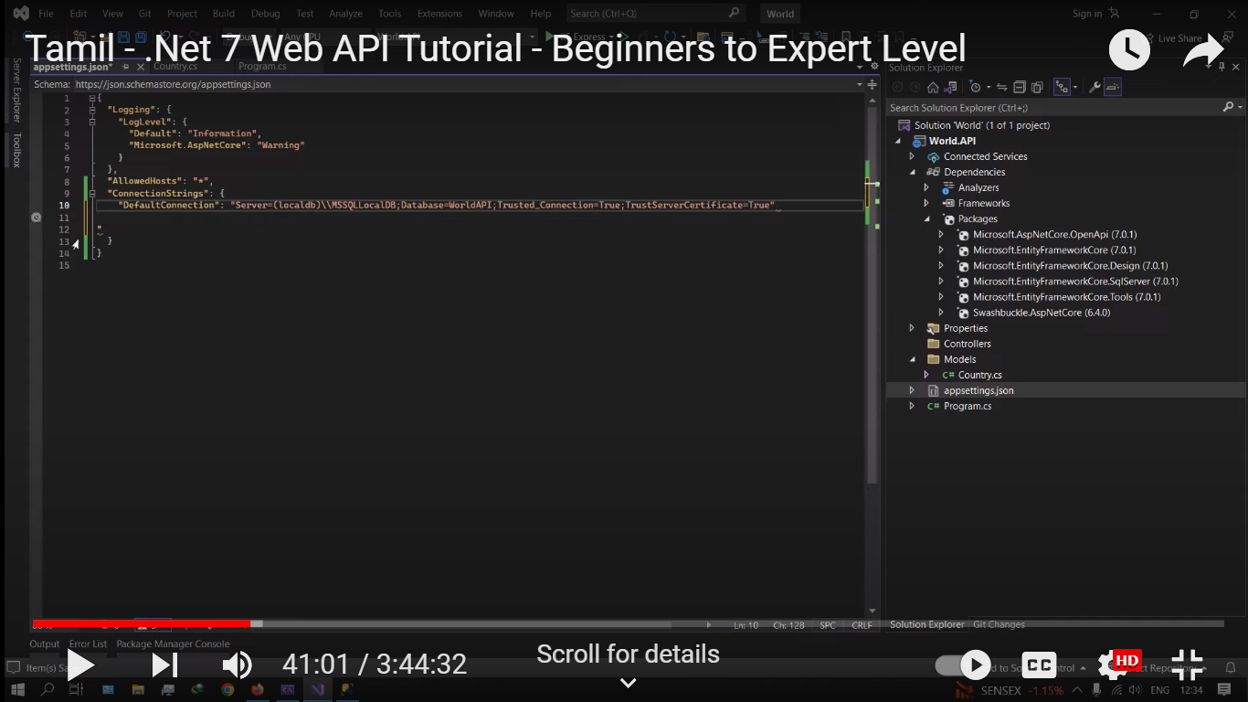

Dbcontext file:

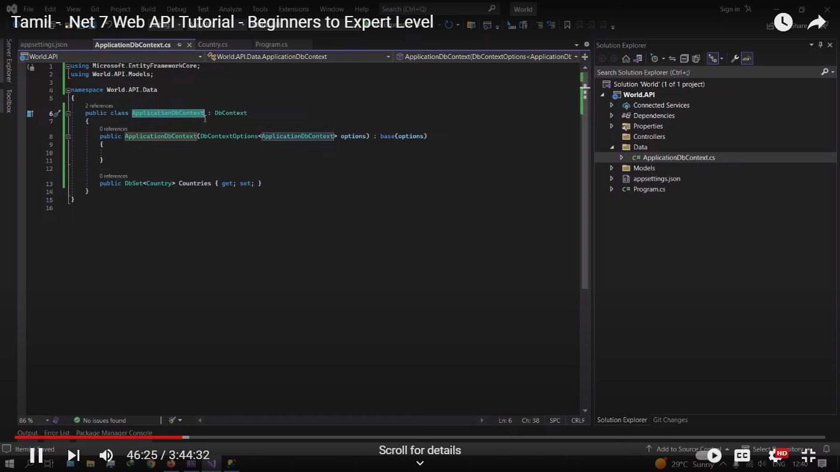

Configure the db context in program.sc

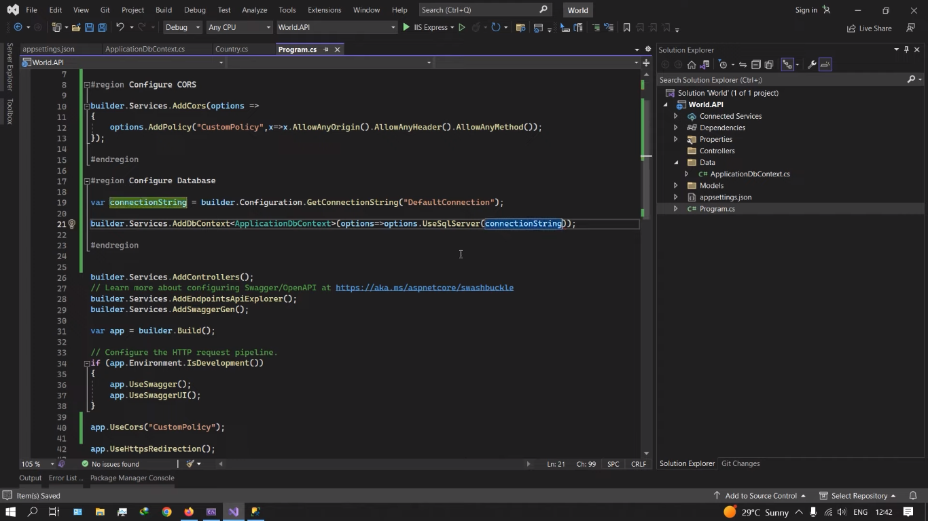

If data base has the username and password we can configure the that name also in connection string

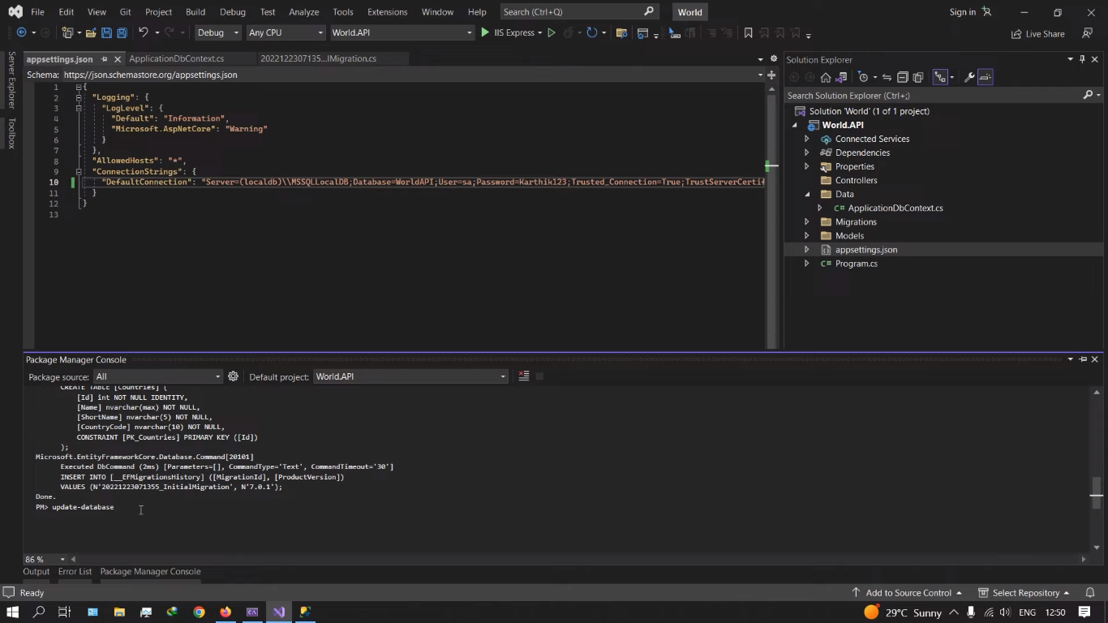

Status code :

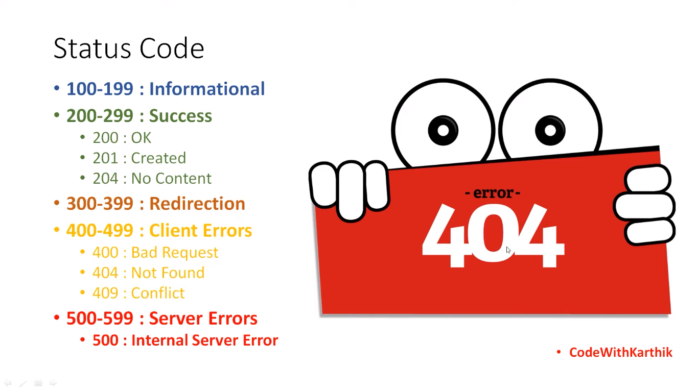

Response type ku taglaye enna nu document pottuklam produceResponceType nu default .net la iruku

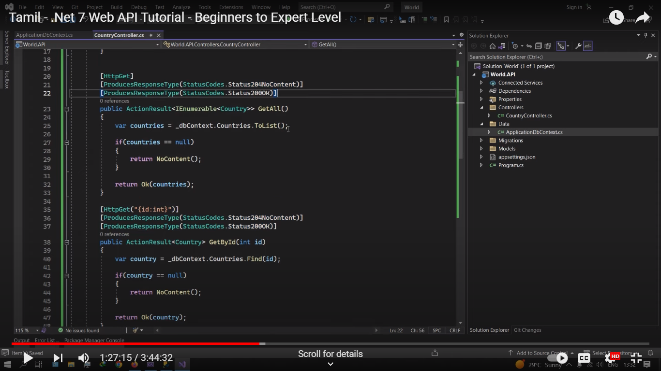

Post method la already data irukkuna again post aaga koodathunu business logic

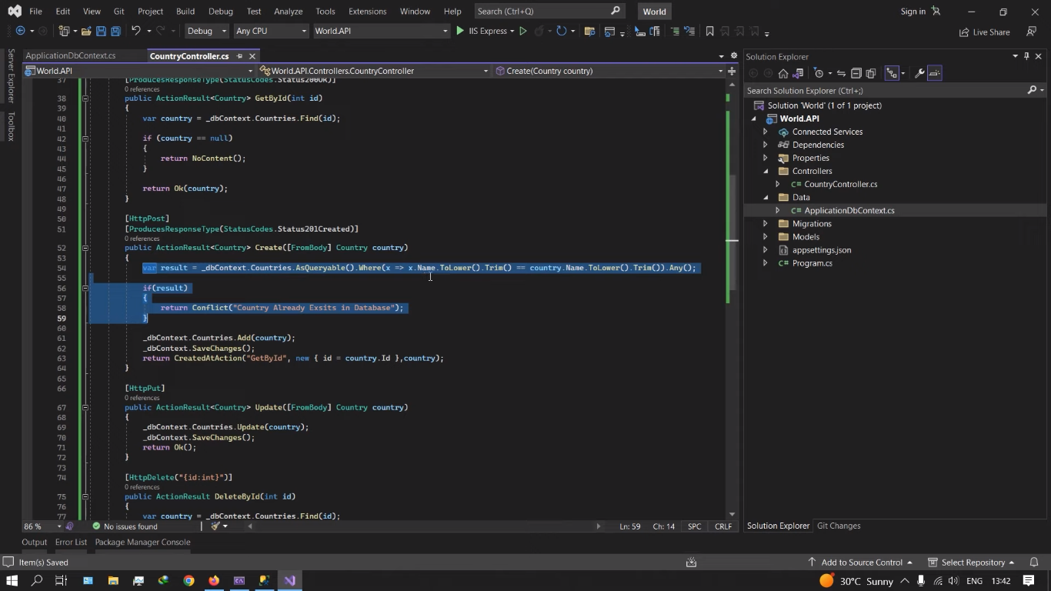

Ithula any()-> method Boolean return pannum

Create action vathu namba data post aachinu get by id la check panni sollu dynamica

Antha create action kulla antha getby id method pottuttu enta dbla id eduthu check pananumo athulaye check pannikkum

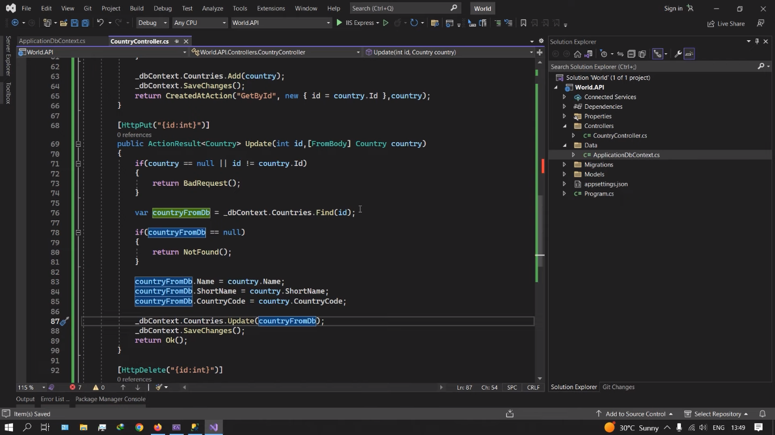

Ithu simple first namba kudukkura data valida nu check pannum then namba kudautha data dbla irukkanu find pannu then data iruntha dabase la iruntha old datava naba new datava kudukurathu update pannikkum

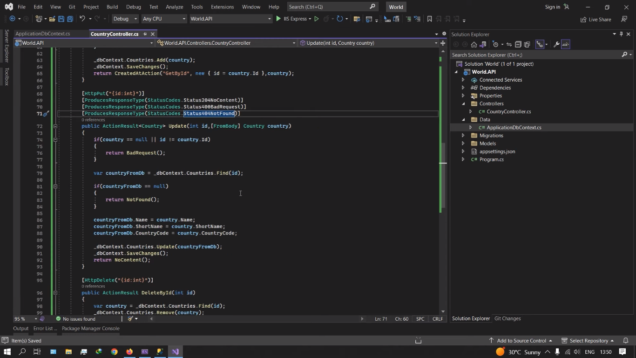

Delete :

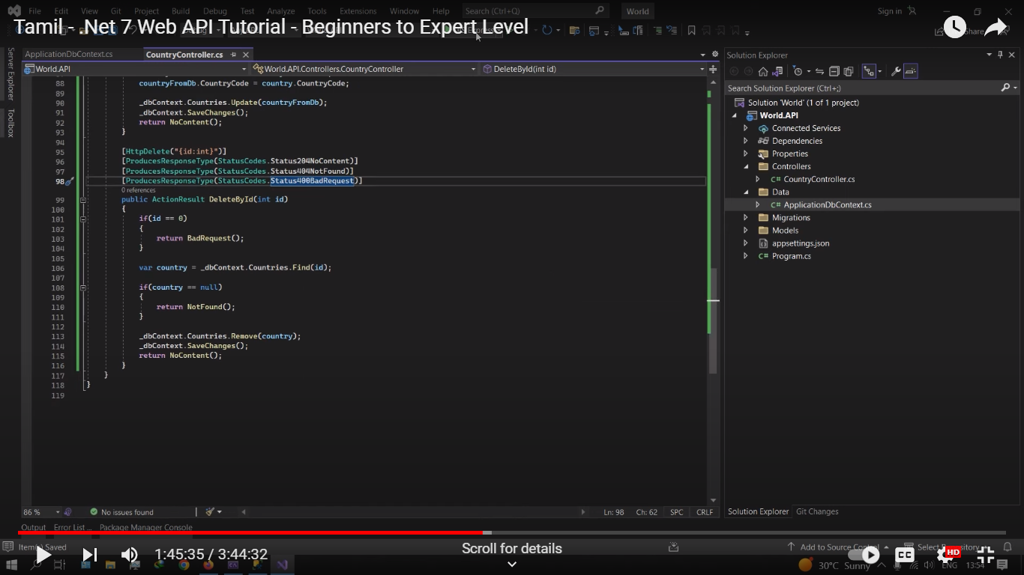

Ippo database la upload panra model la irukka field user ku kaatama hide panatrthukku rendu model create [panni oru model la primary key irukka maari mathathula rendume sameaa iruka maari irukkanum post methodla primary key illatha model la datava vaangi db la set panrappo db original model la save changes la kudukkanum 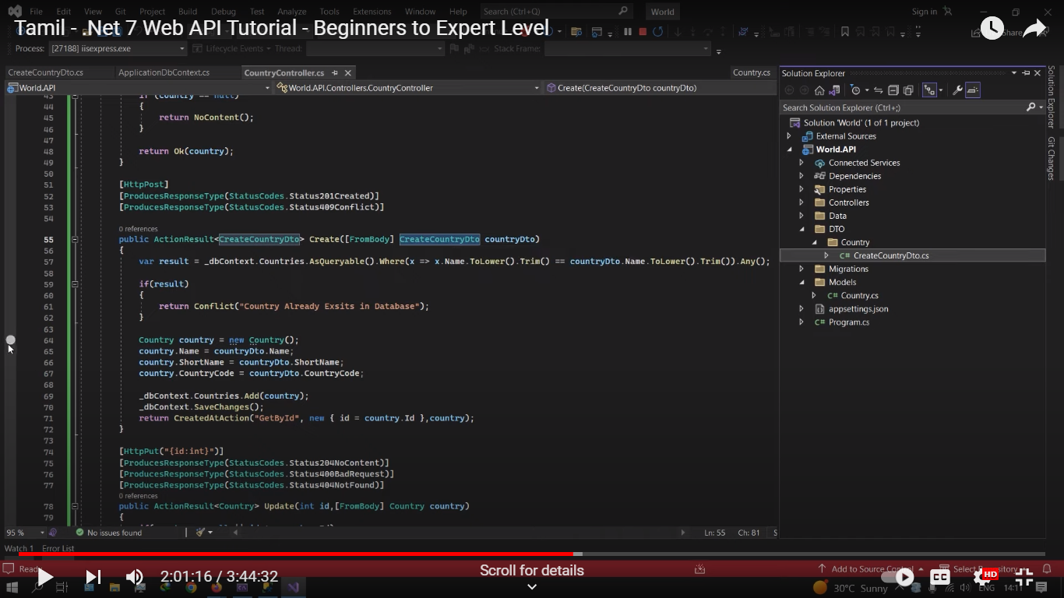

Ithula data va assigh panarappo code short panna auto mapnu irukku atha install pannaum

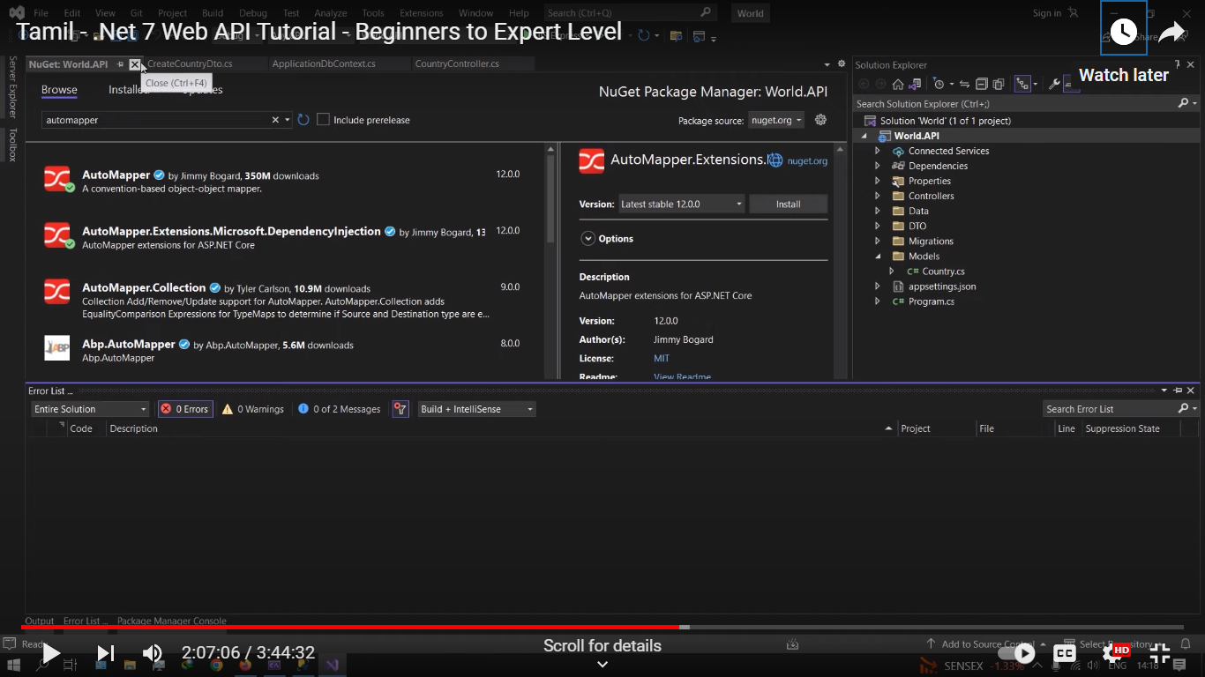

Auto mapper panrathukku oru class file la sourse model then destination model kuduthu.reverse map na intha modelairukka data ithukku assign aaguthunu

Apro configure panniranum

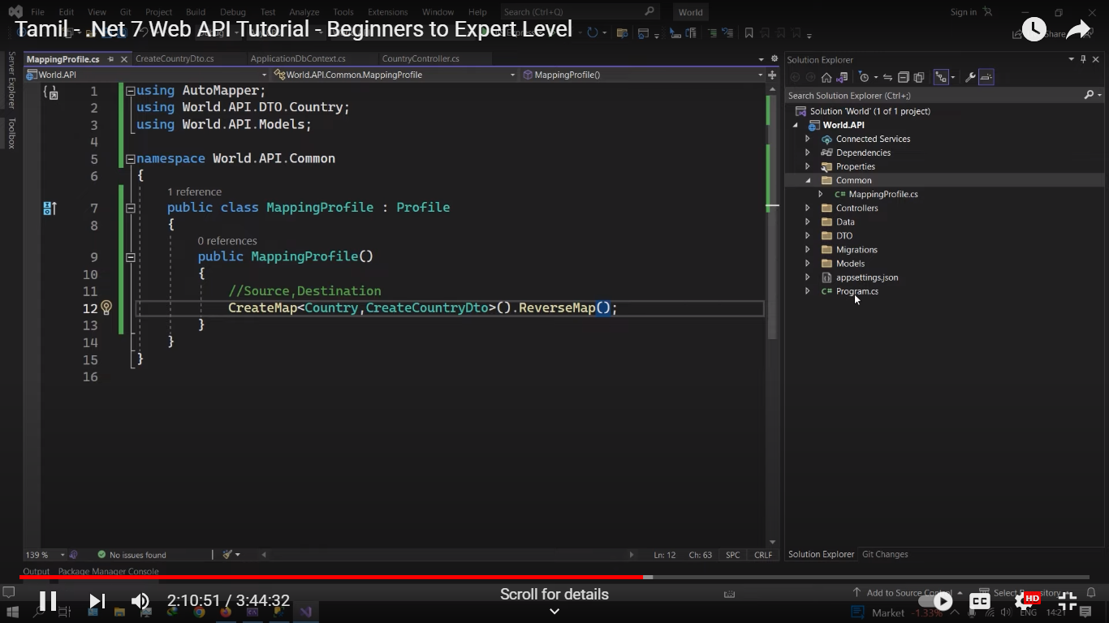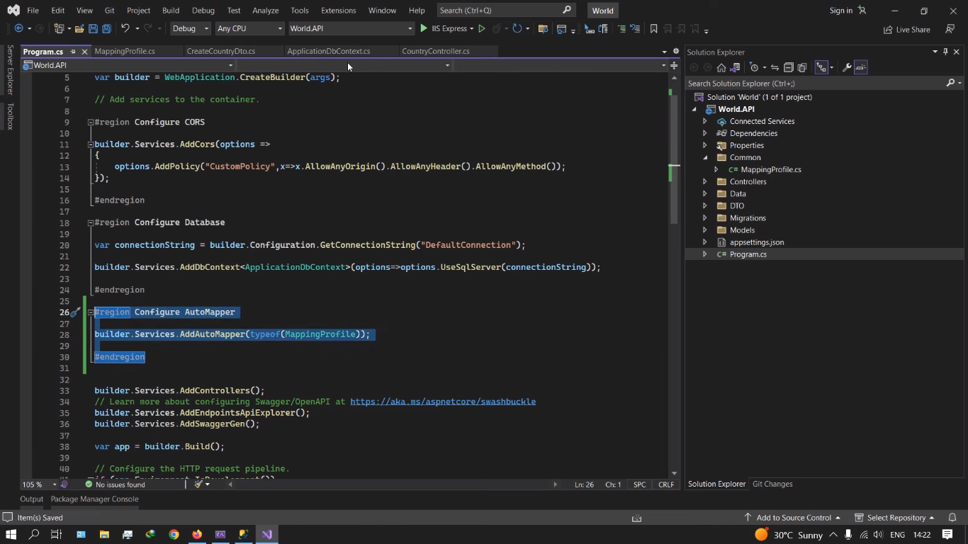

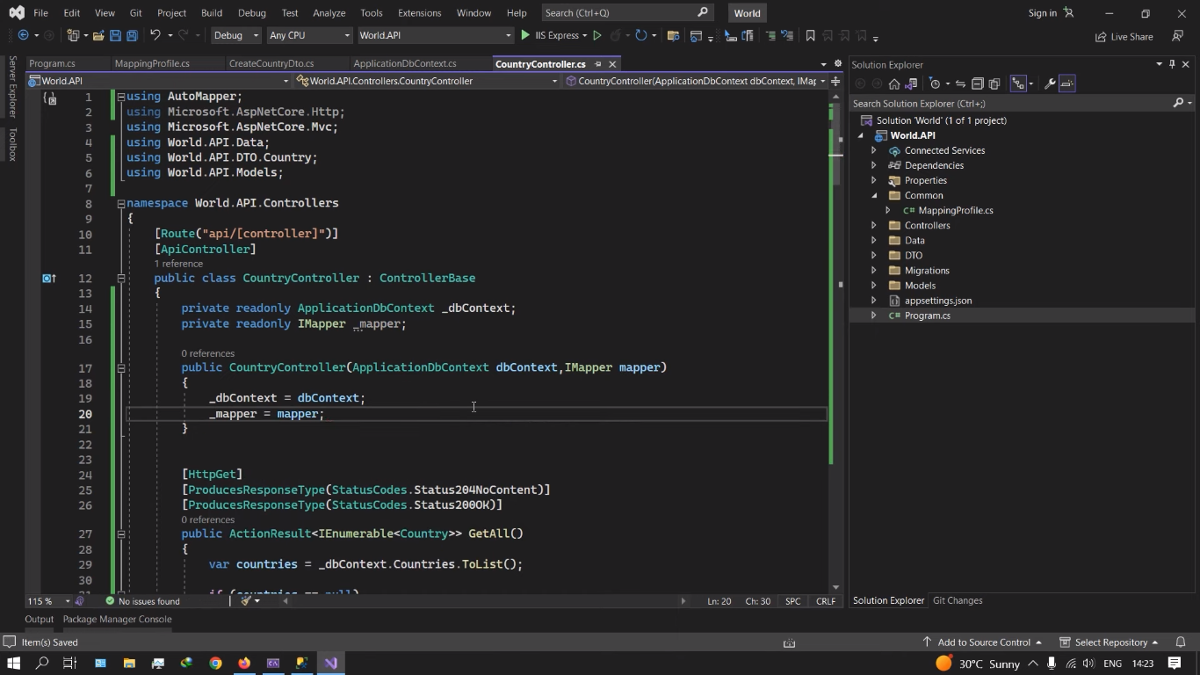

Single line code 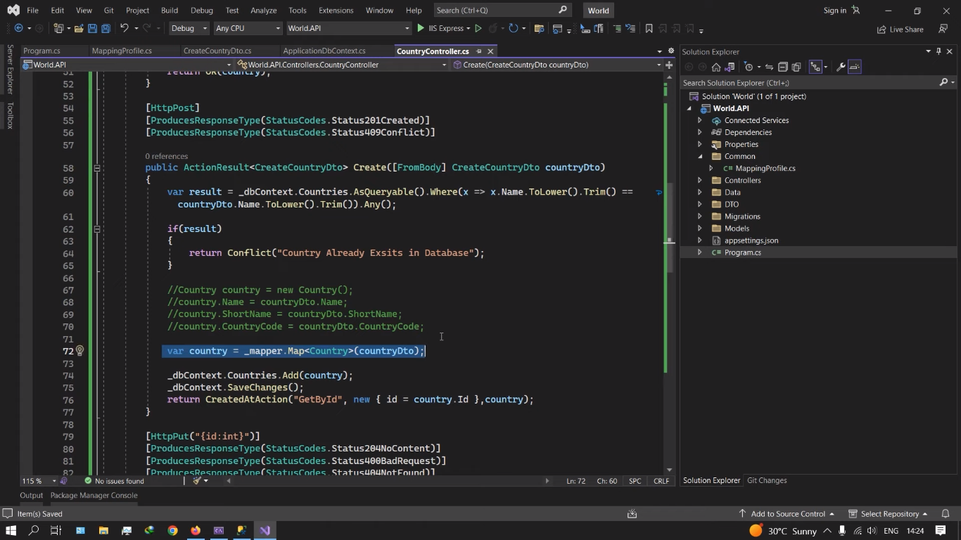

Repository pattern:ethukku use aguthuna database directa contollerla or service la use panama repository moola access panniklam

Interface:not implemented code it has only overla operation methods

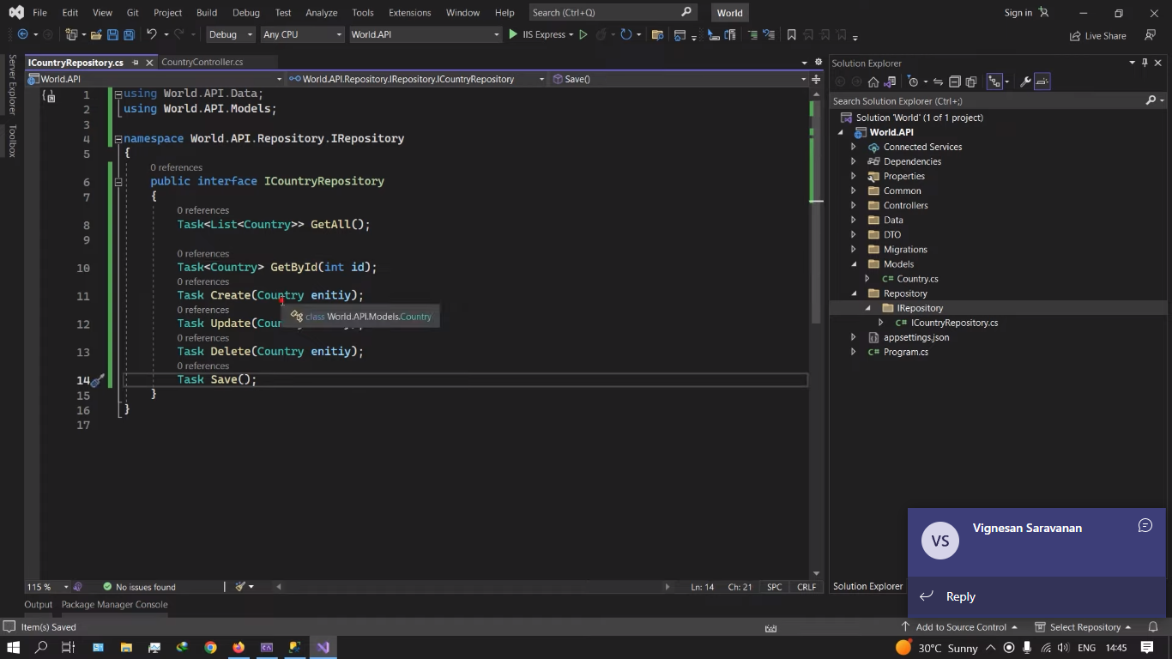

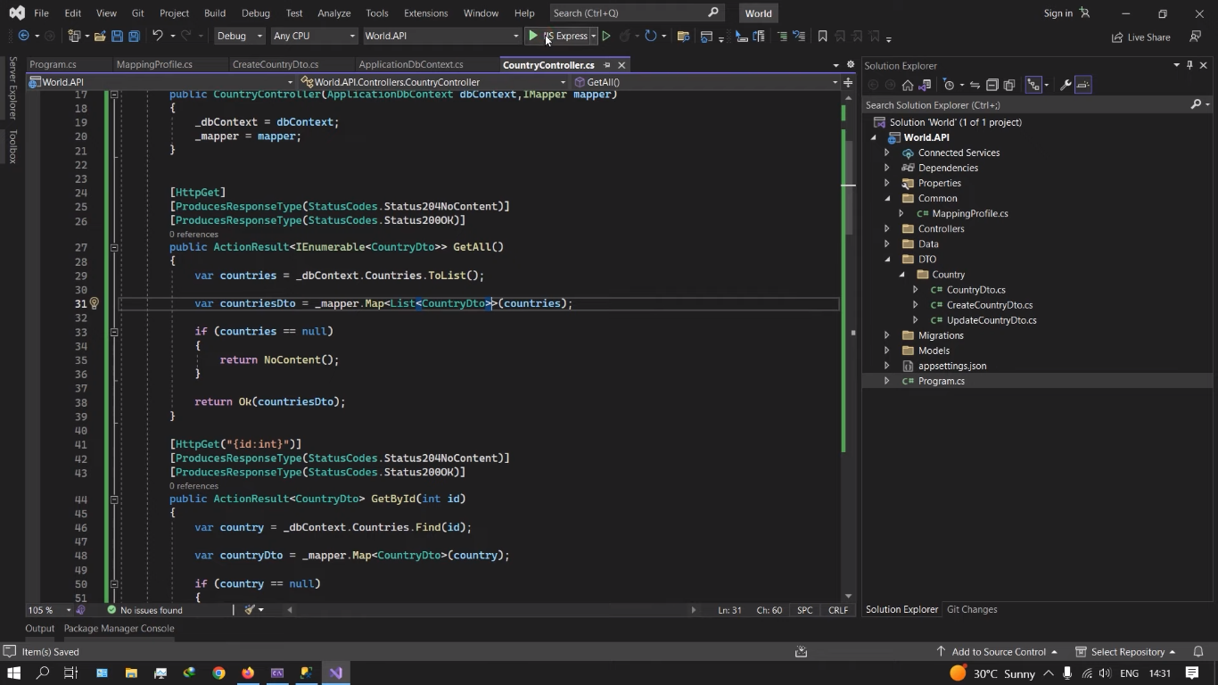

File formate :

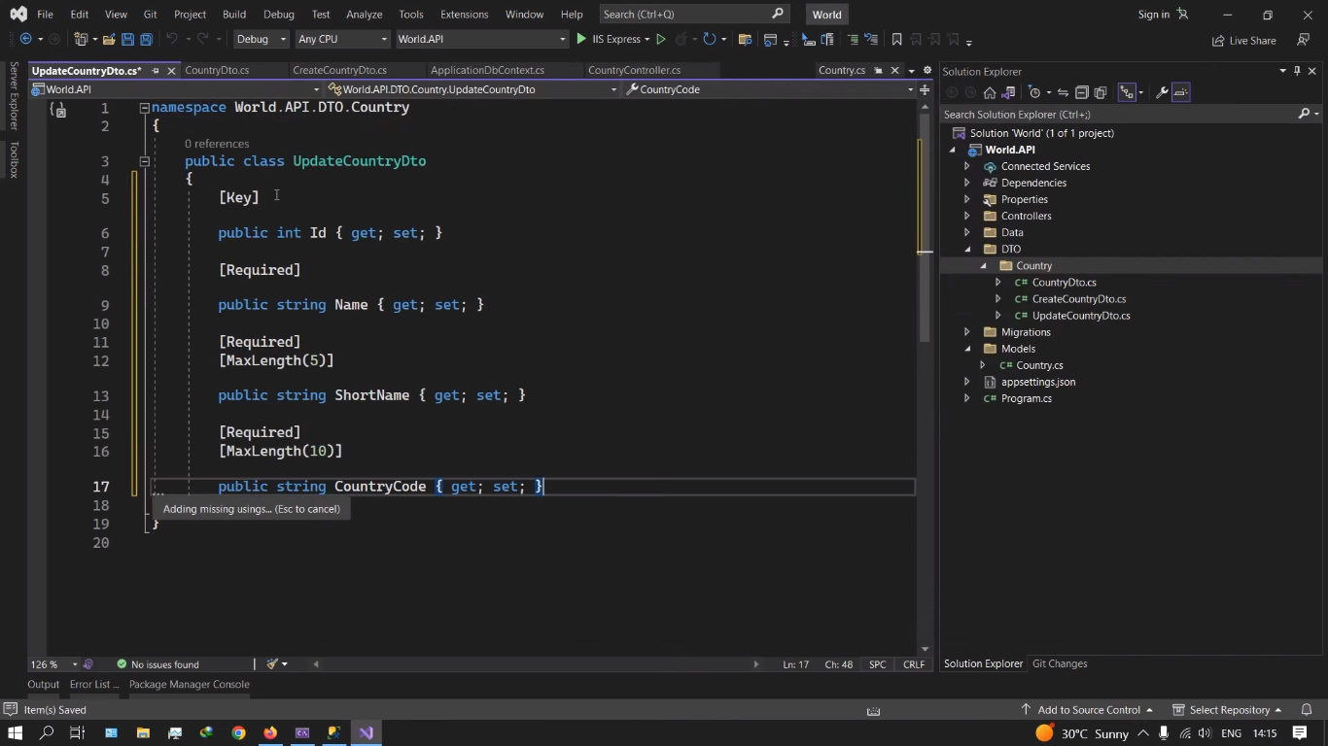

Repository pattern:

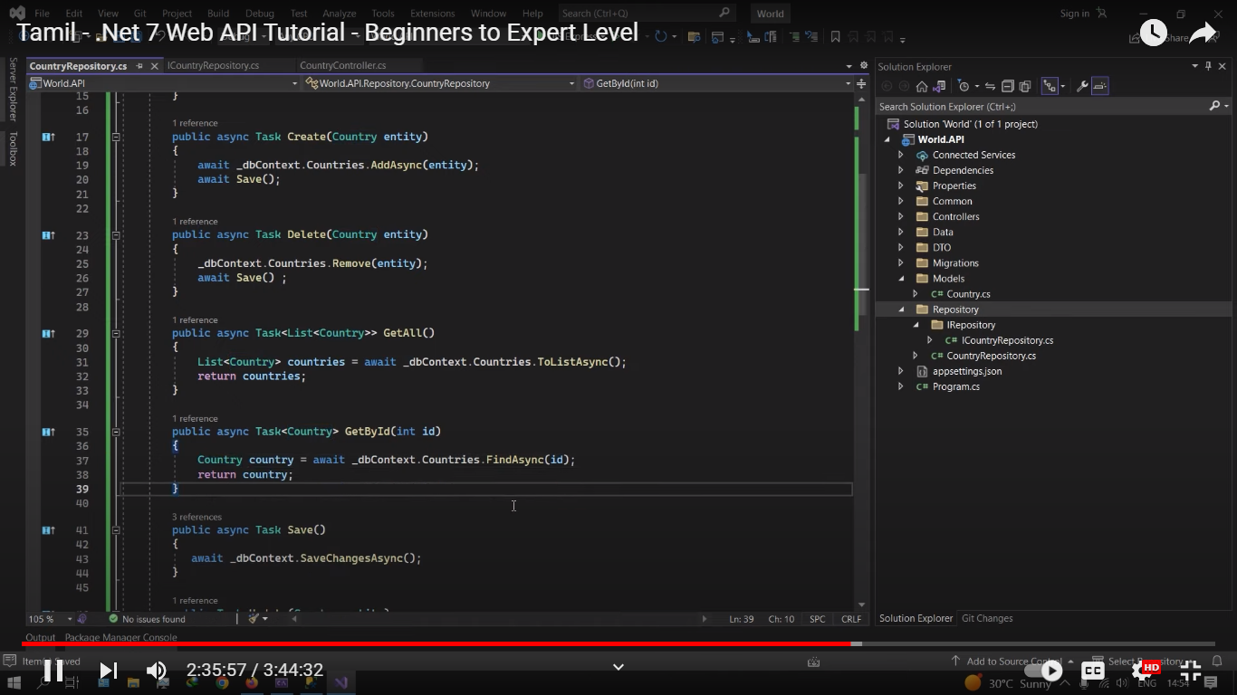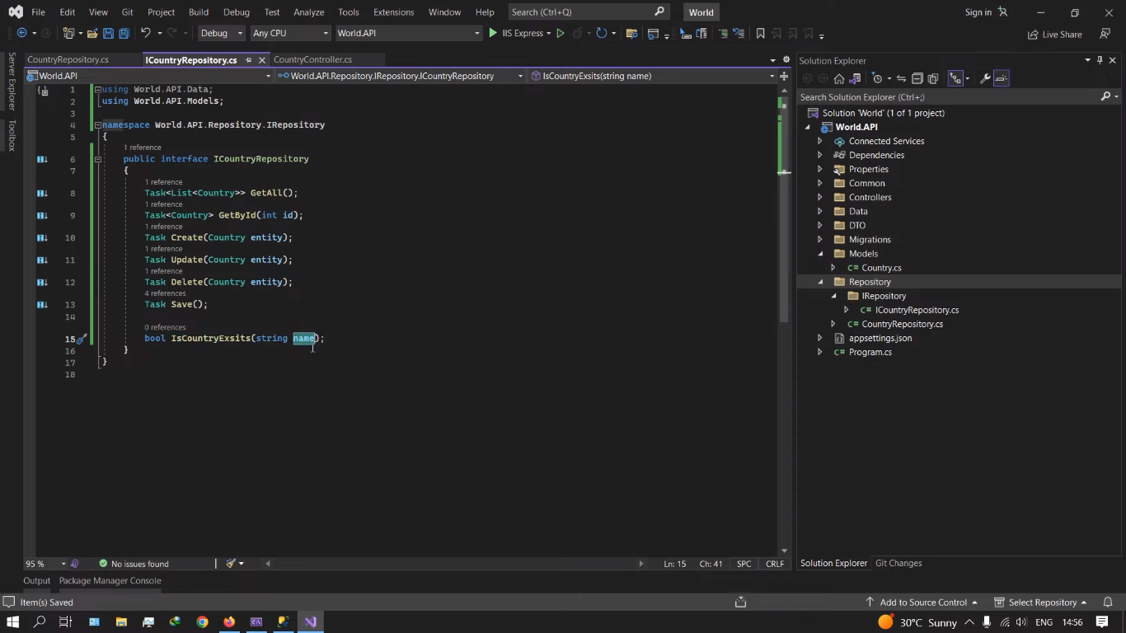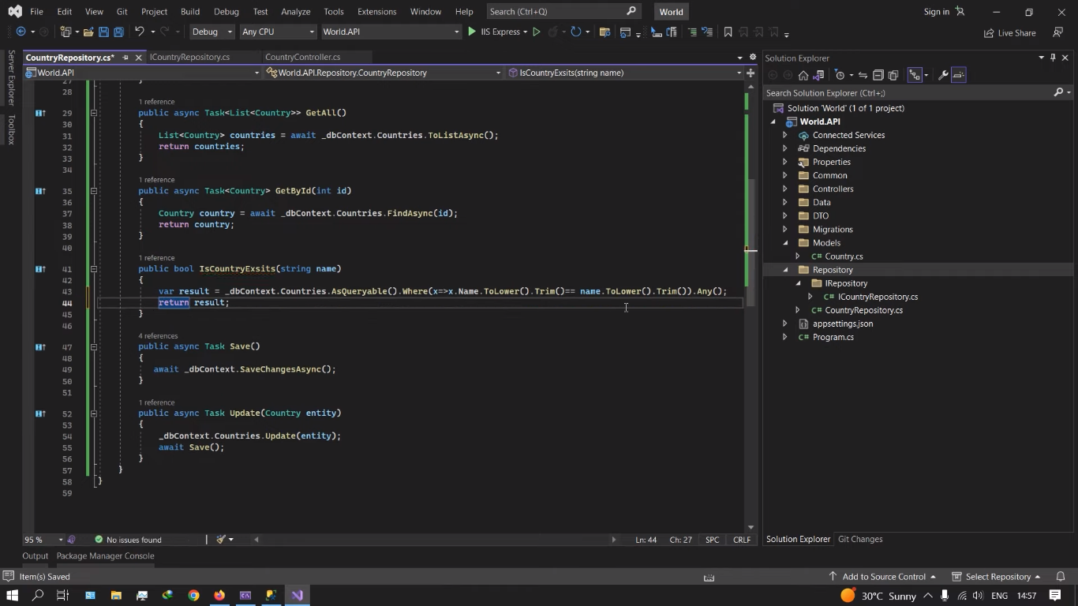

Controller la panra hard code implementation la interface repository class laye panniklam

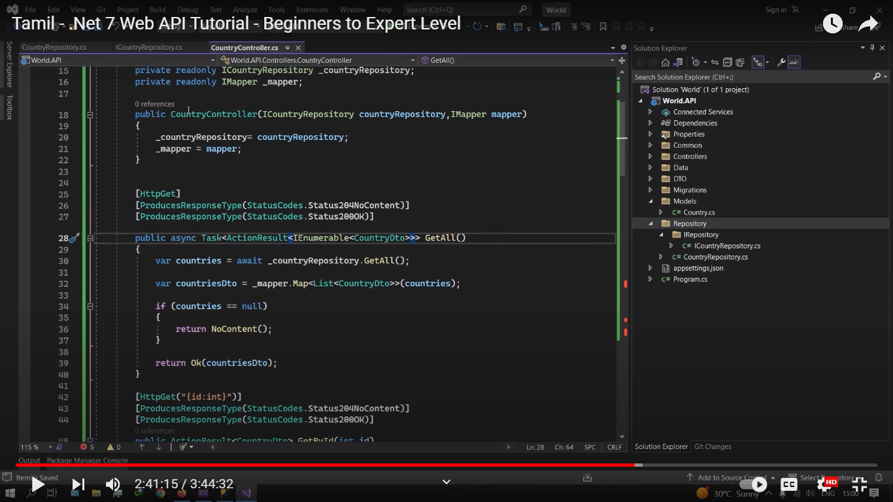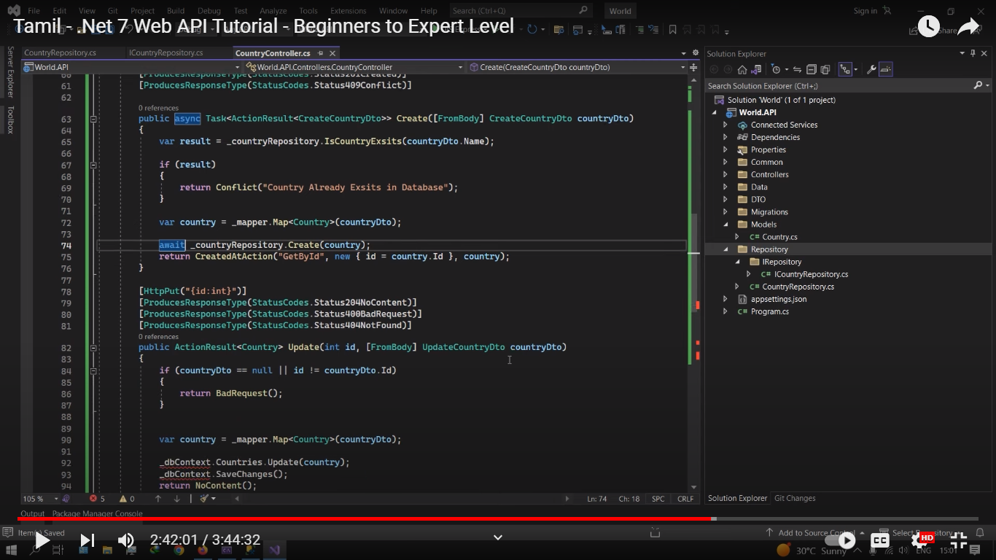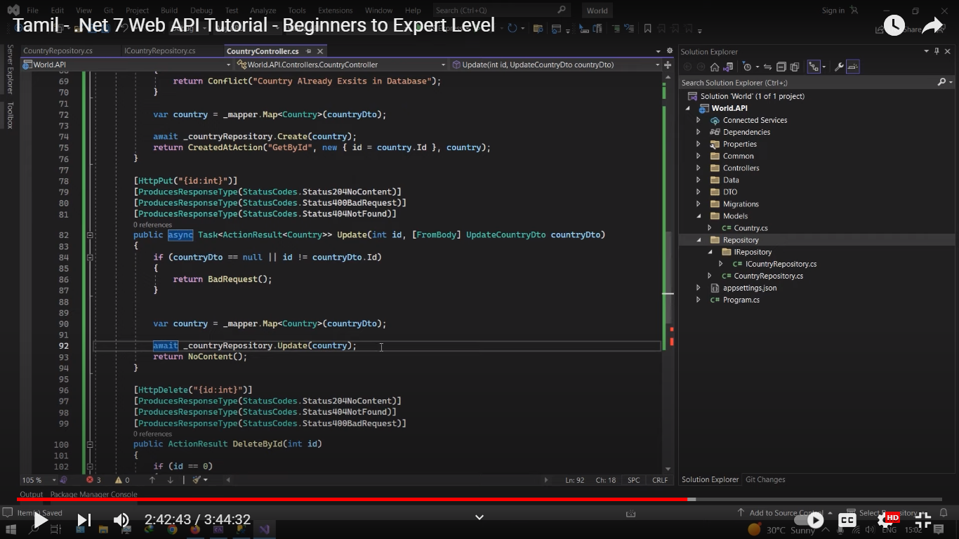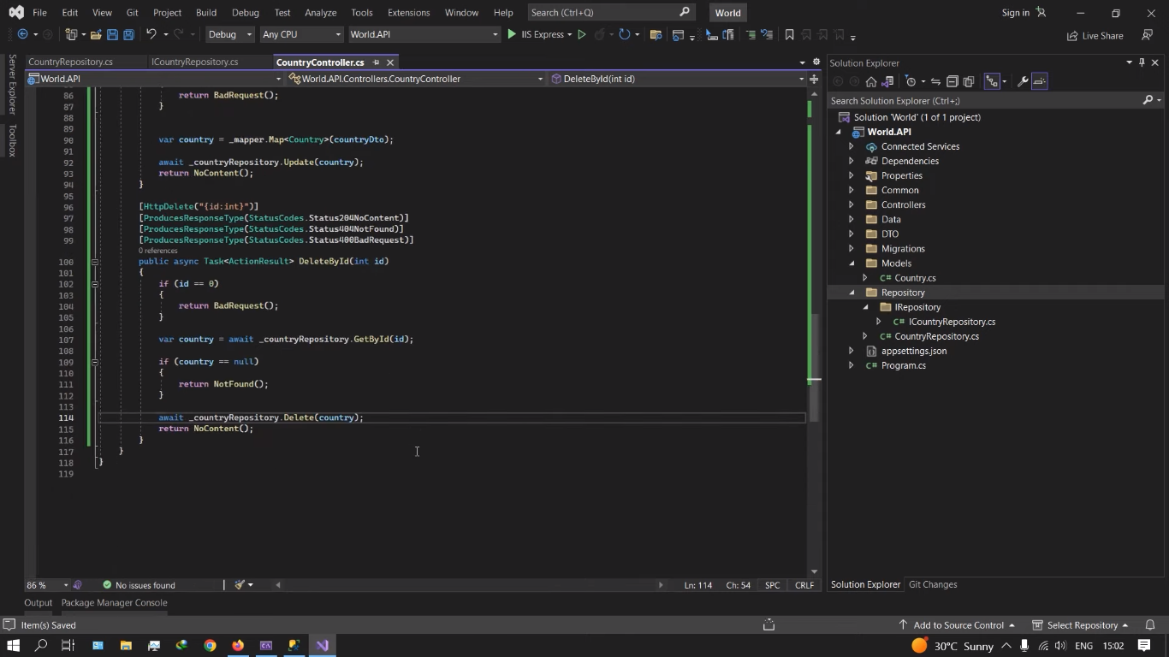

Then repository irukkunu program filela configure pannanum

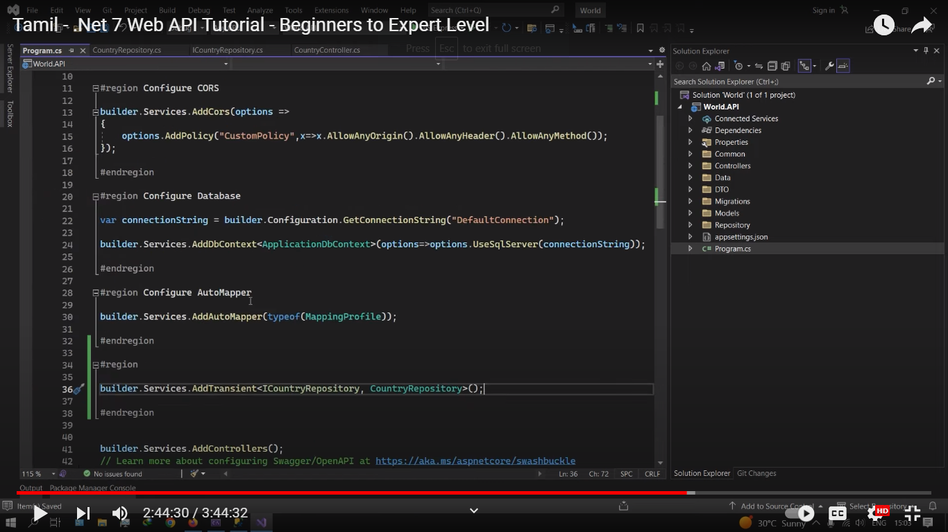

Generic repository:

Ithula T ethukku kudukkuromna antha model class replace aagikkum

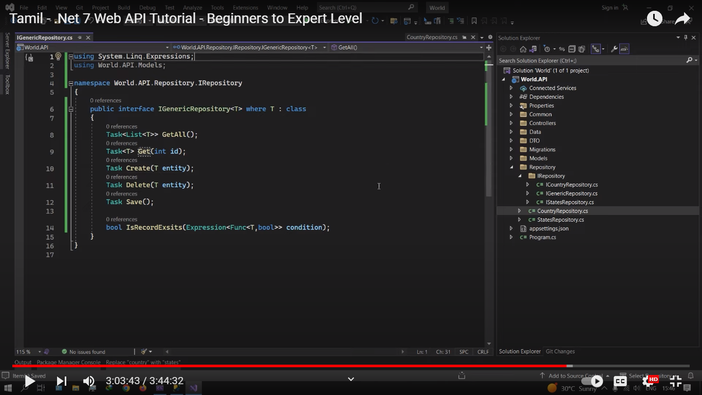

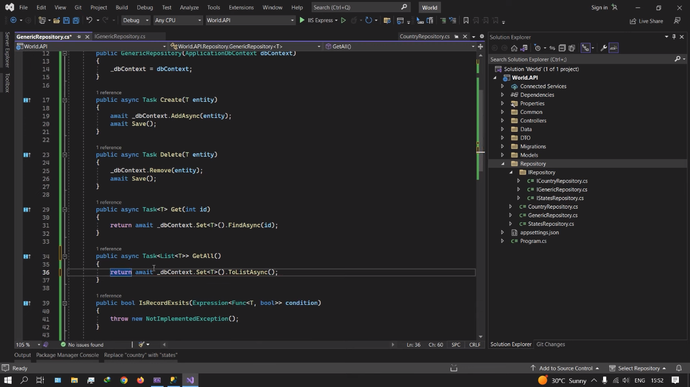

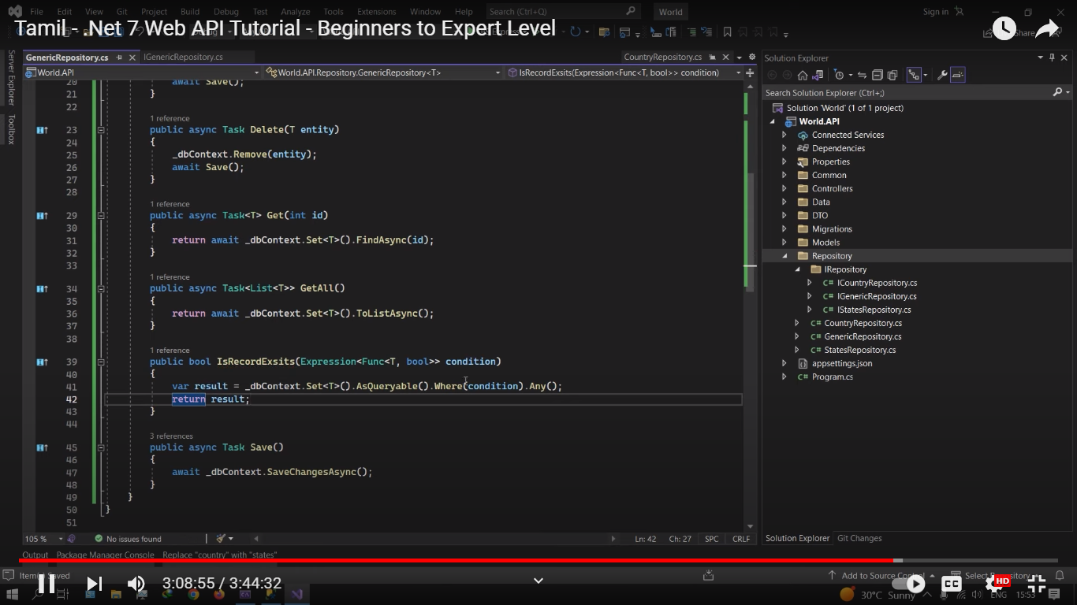

Genericka onnu commana create panniyachu then antha commonku ella model repository interface layum then repository class layum inherit pannanum

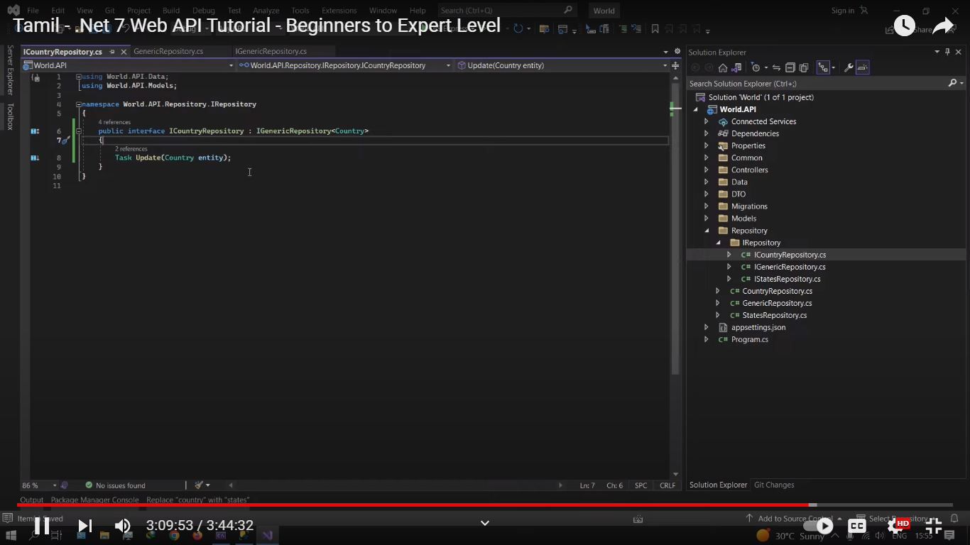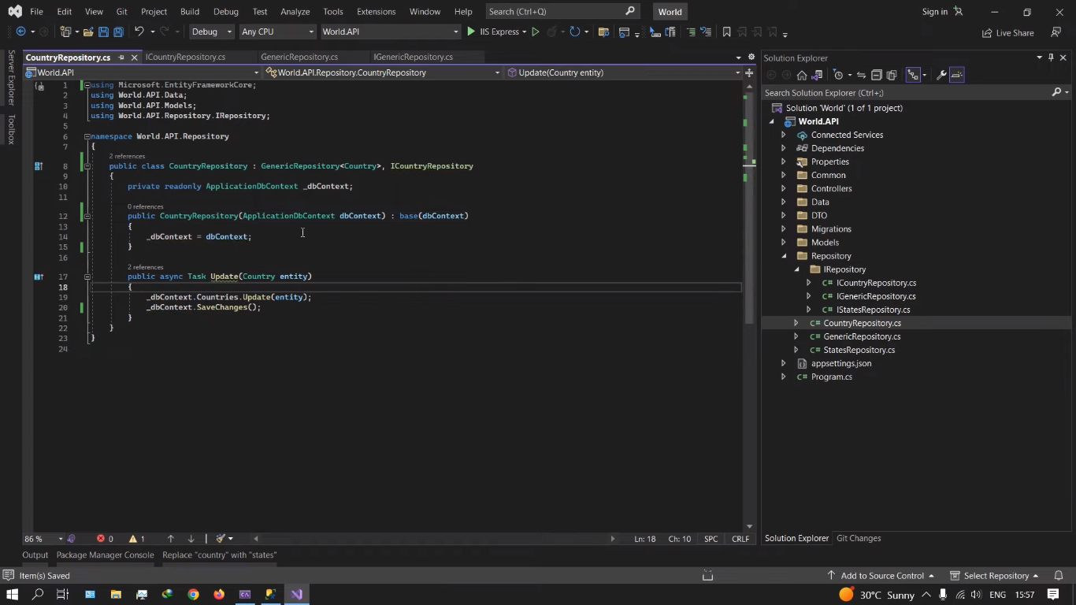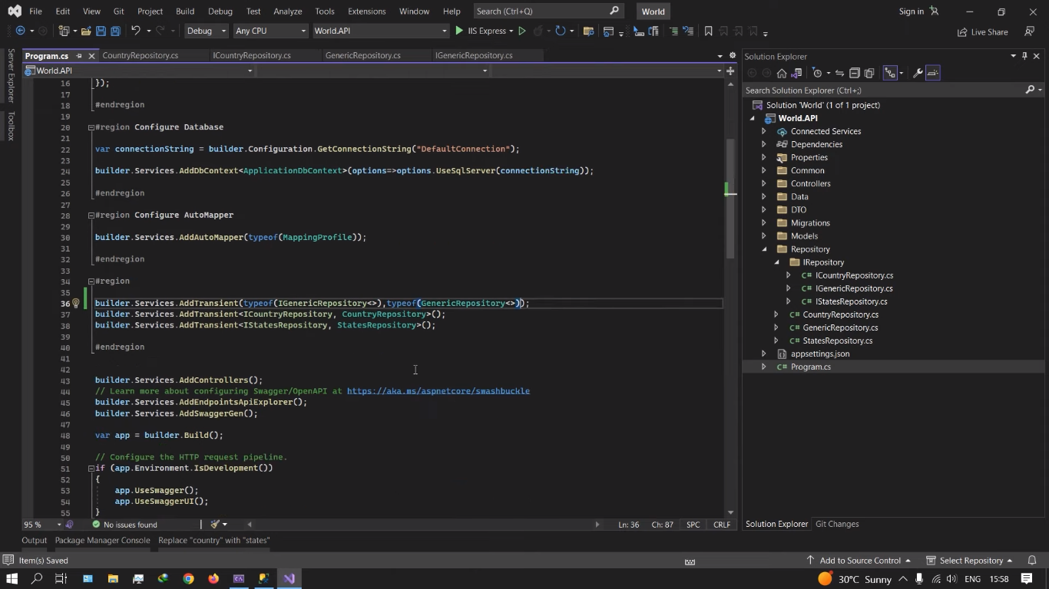

Generic repository configure pannaumu () braket tha use pannaum . ella maathitti controllerlayum china change pannaum

